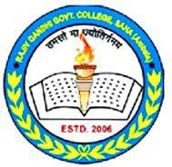

Rajiv Gandhi Government College, Saha (Ambala)
(Affiliated to Kurukshetra University Kurukshetra)

3.2.2 Workshops/Seminars/Conferences
Session 2024-25

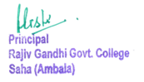

Index
Sr. No. | Workshop/ Extension lecture topic | Date | Page No.
1. | Seven days Sanskrit Workshop | 28 Mar – 05 Apr 2025 | 3-5
2. | Workshop on Research Methodology and Service Rules | 10 Feb - 15 Feb 2025 | 6-9
3. | Seminar on Indian Knowledge System and Modern Subjects | 10 Jan 2025 | 10-12
4. | Financial Education Workshop | 25 Sep 2024 | 13-16

- Seven days Sanskrit Workshop
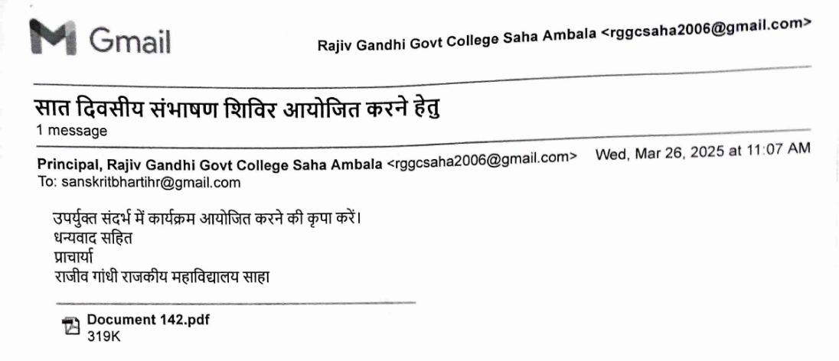

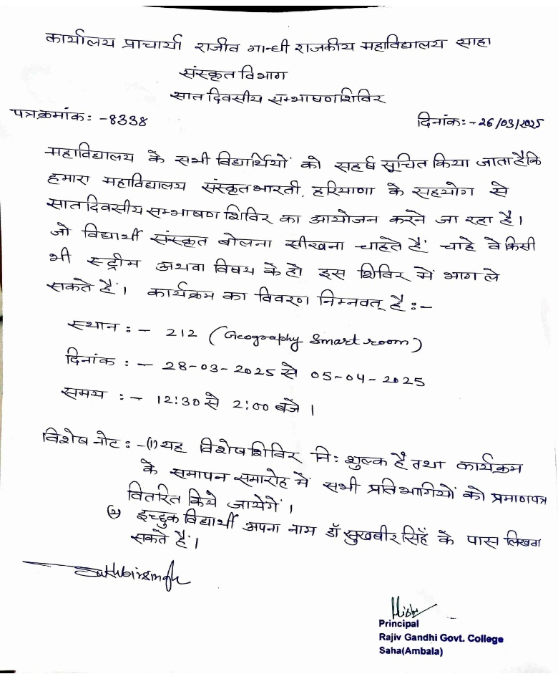
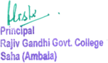

Media Coverage
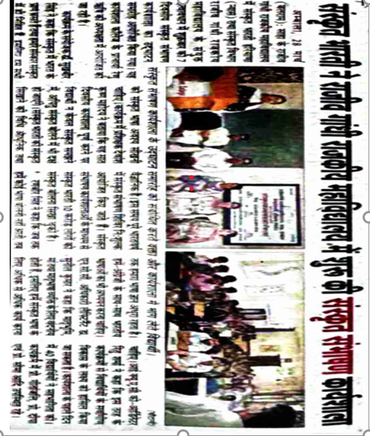
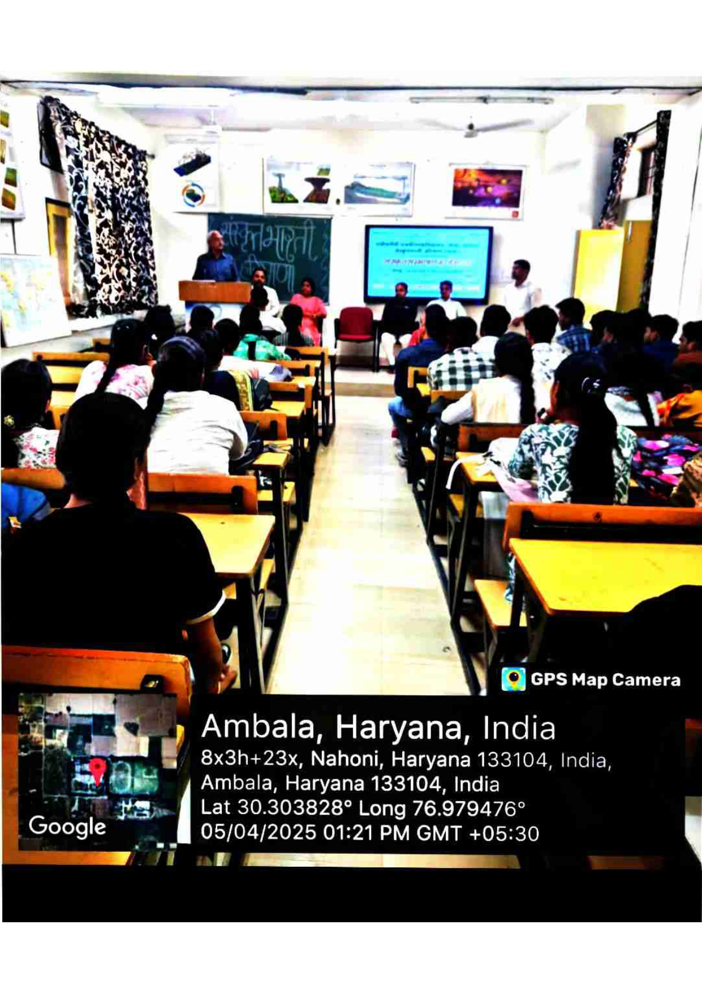
Attendance Chart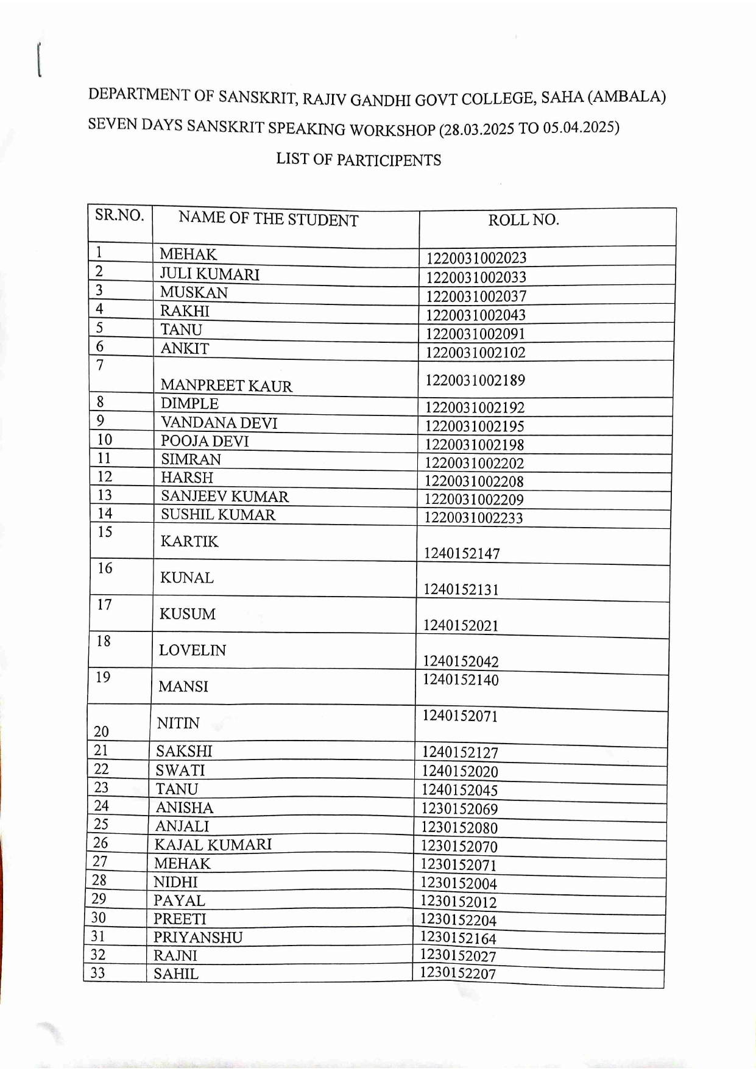
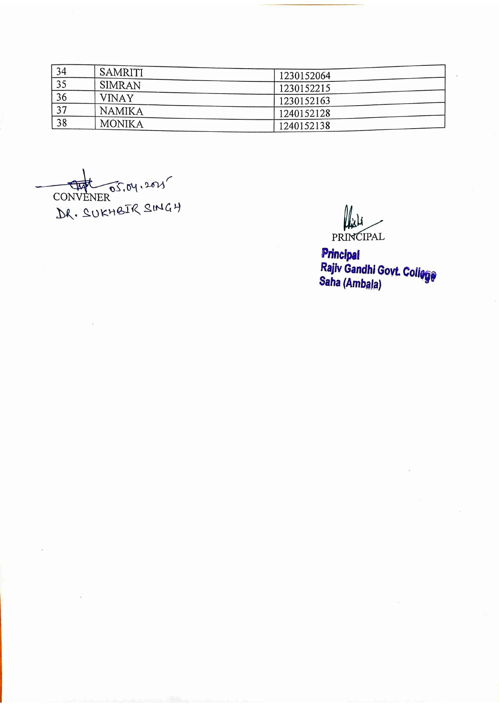

2. Workshop on Research Methodology and Service Rules
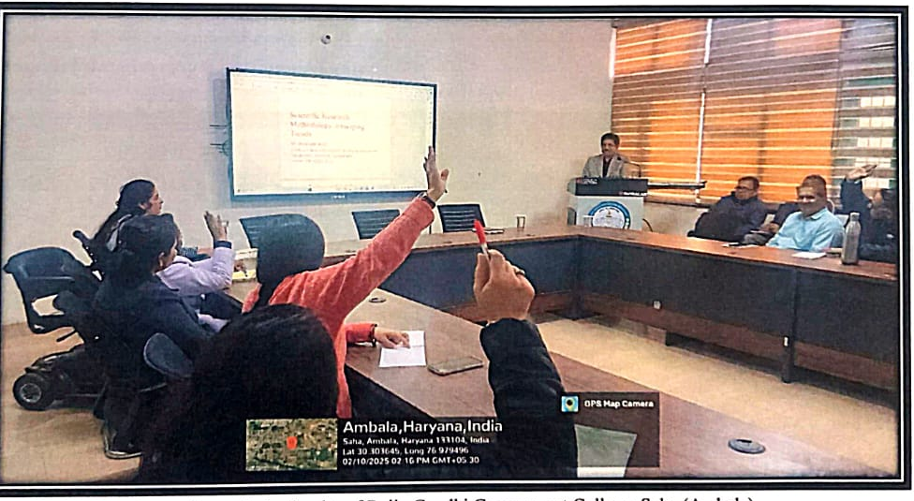

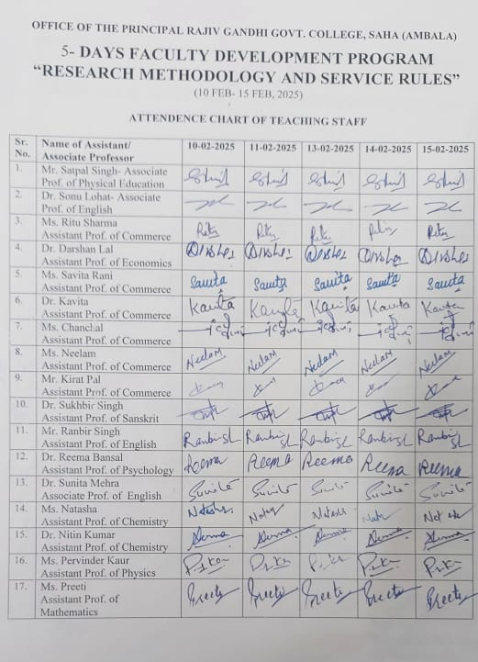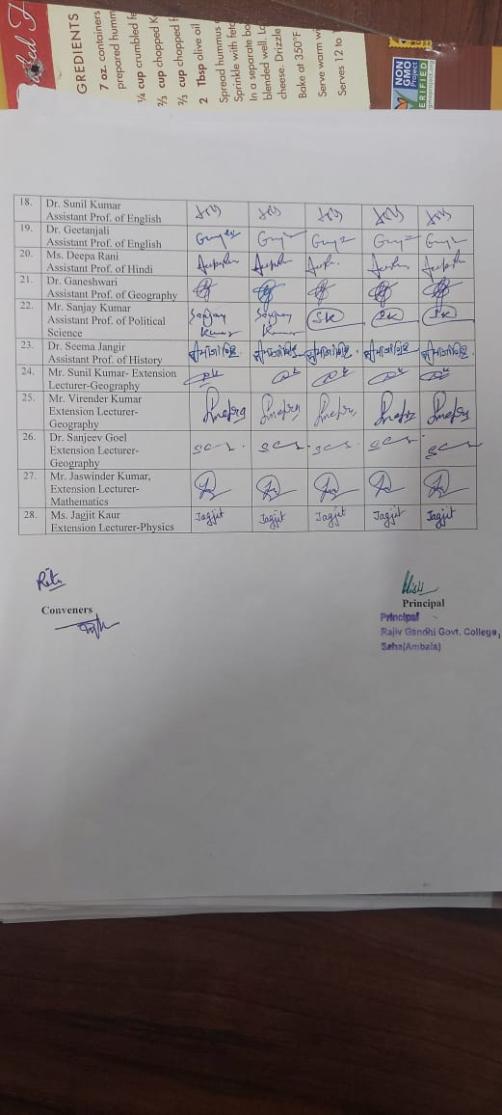

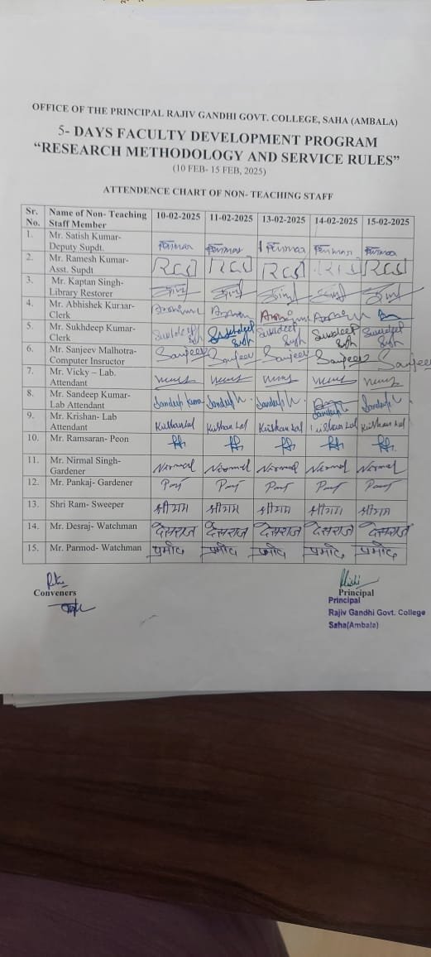

Newspaper Coverage
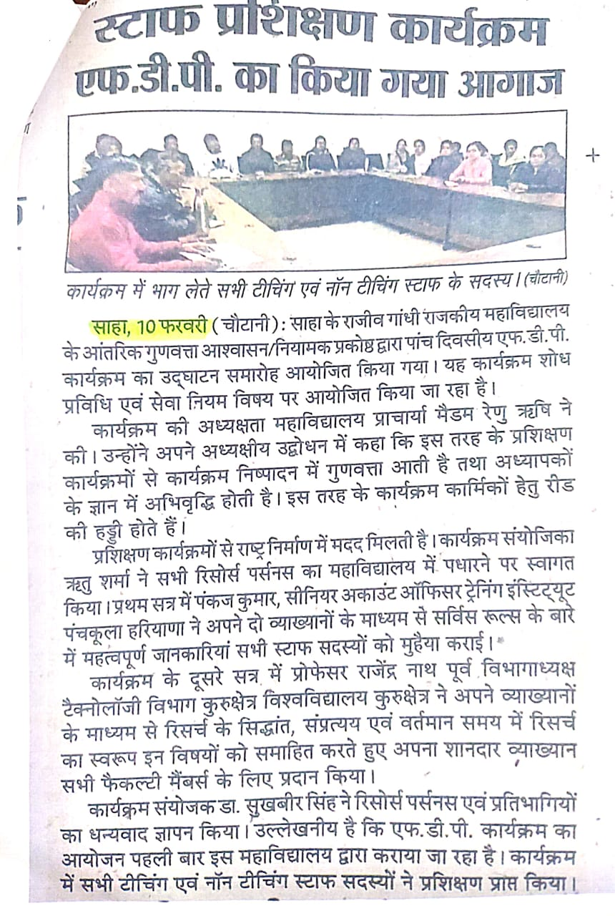

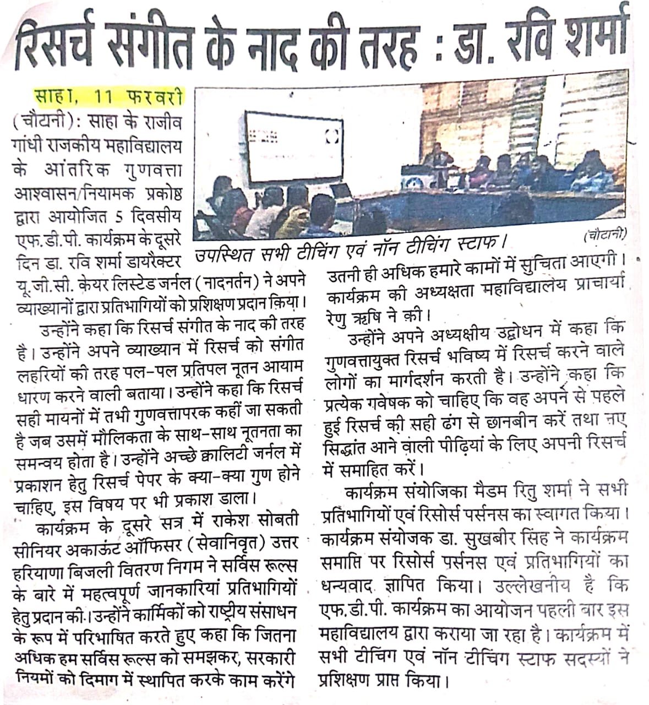

- National Seminar held on “Indian Knowledge System and Modern Subjects”
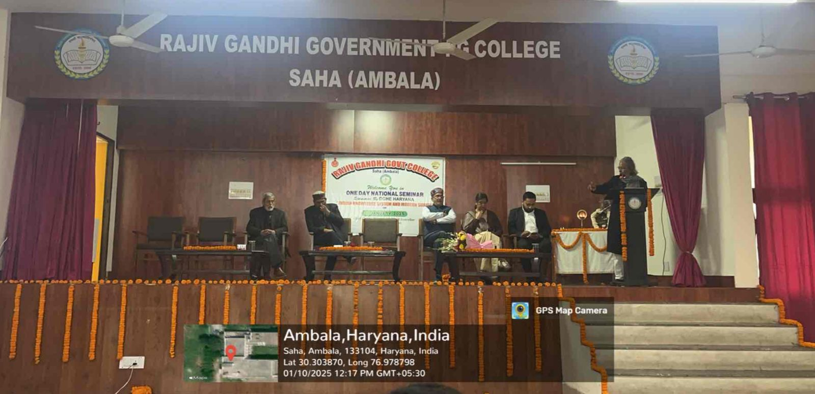
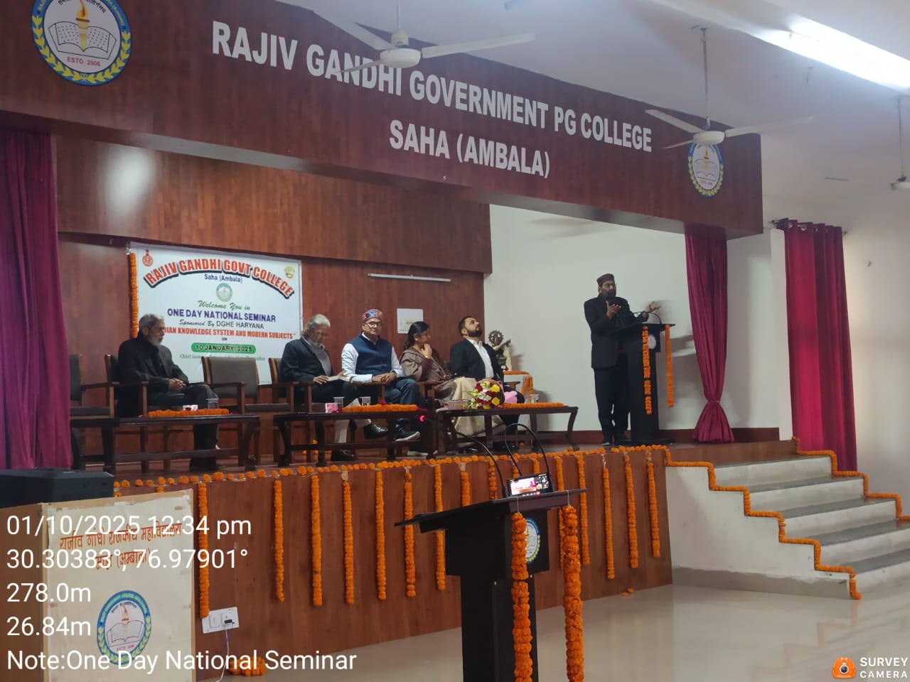

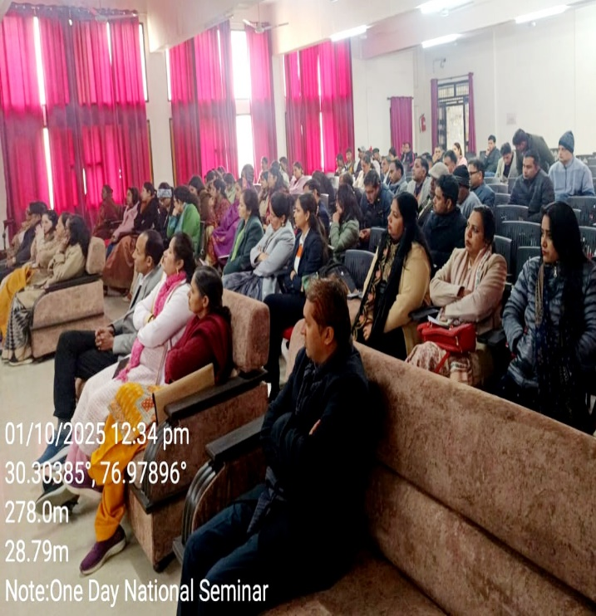

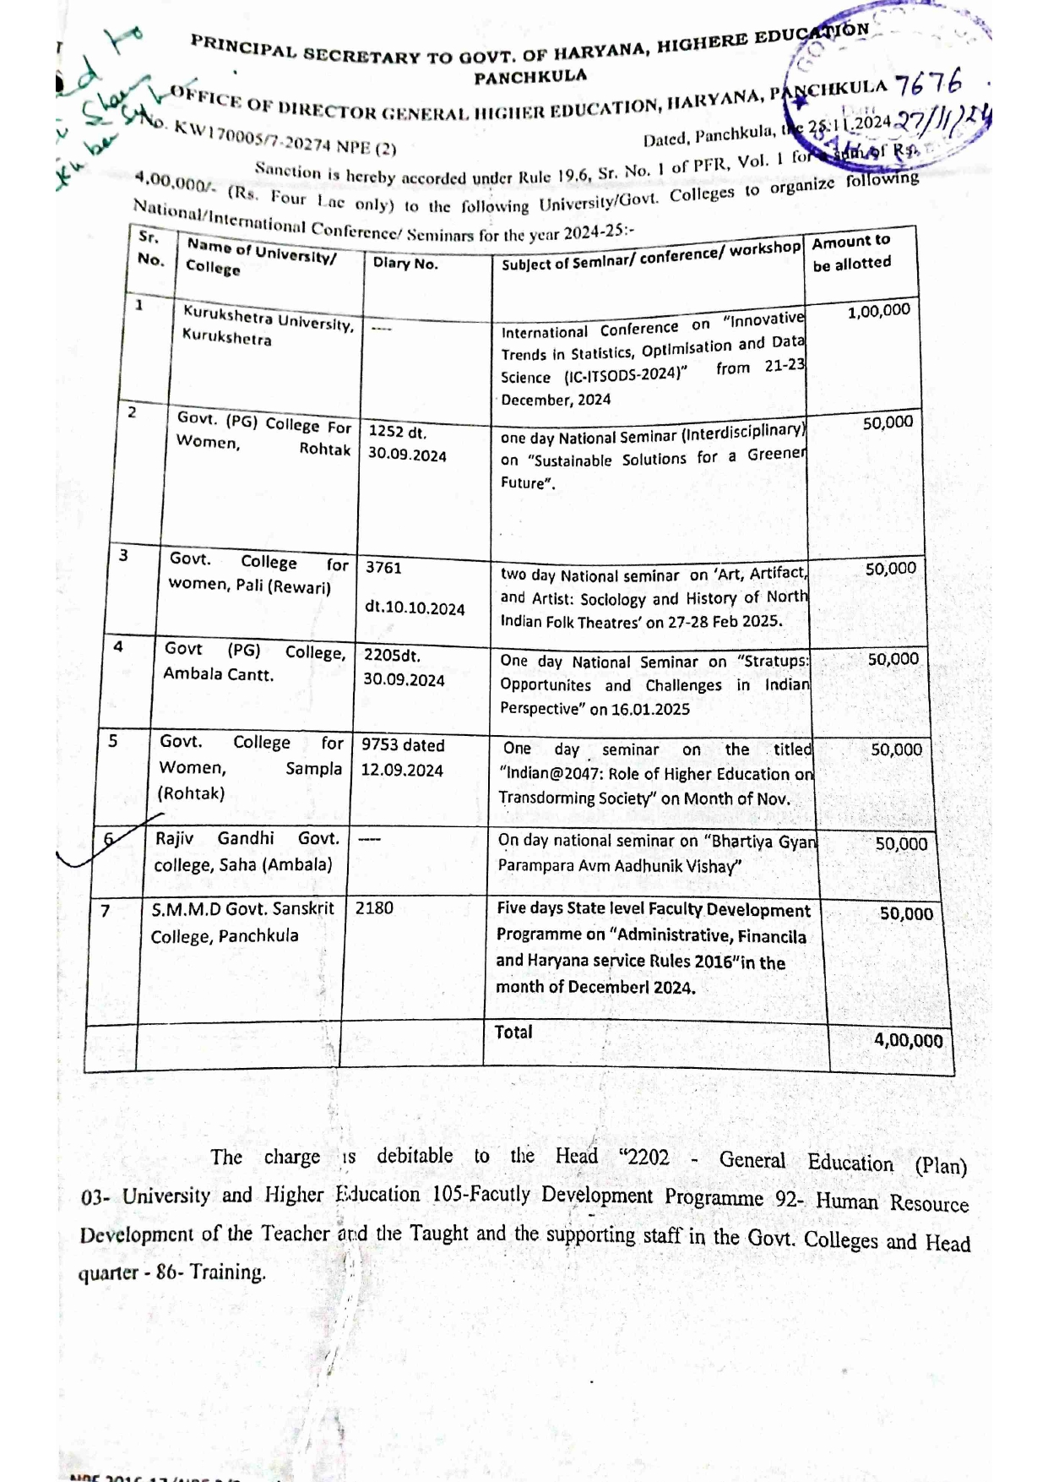

Newspaper Coverage

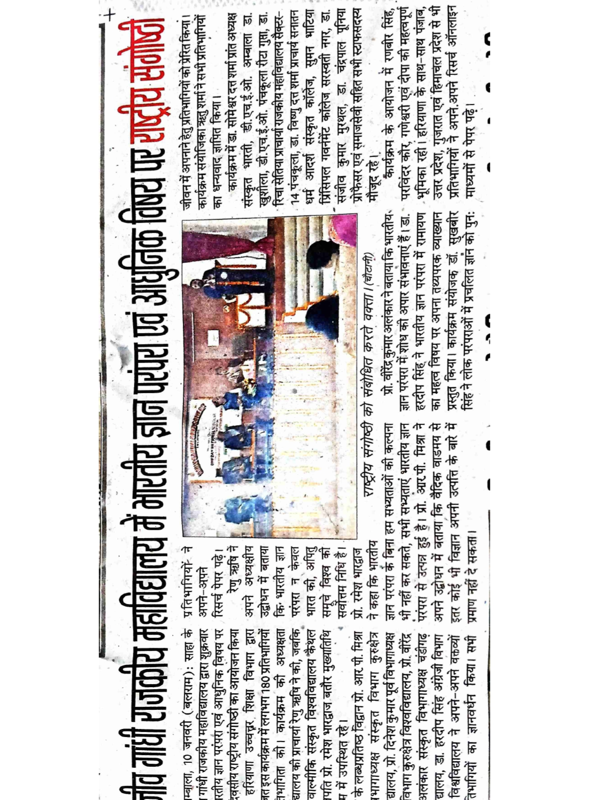

- Financial Education Workshop

