Feed back form responses 2024-25

INDEX
S.no. | Title | Document | Page no’s
1 | Feed back form responses | Students' feedback responses- | 3-17
1 | Feed back form responses | Alumni feedback responses- | 18-21
1 | Feed back form responses | Teachers' feedback responses- | 22-23

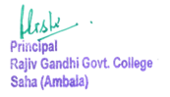

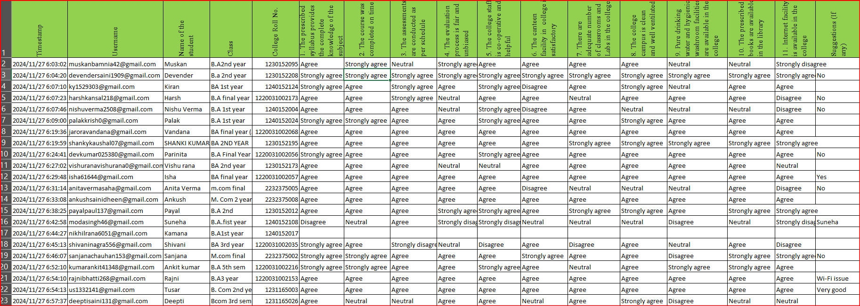
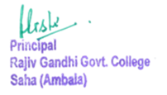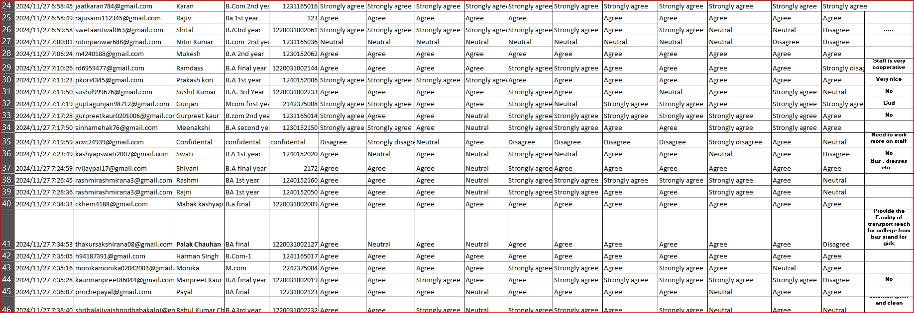

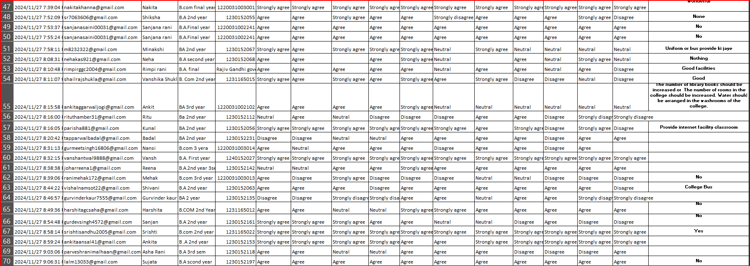

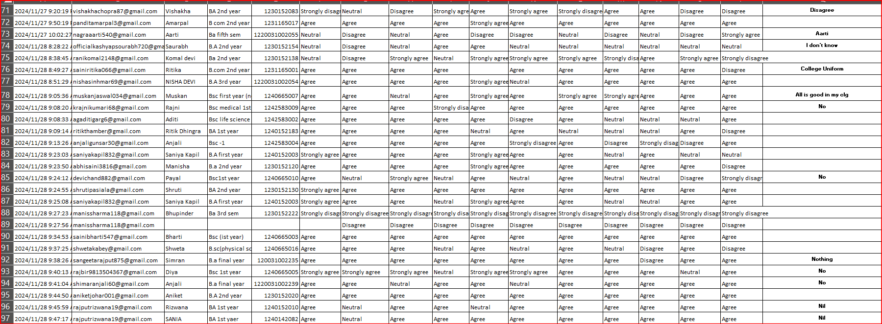
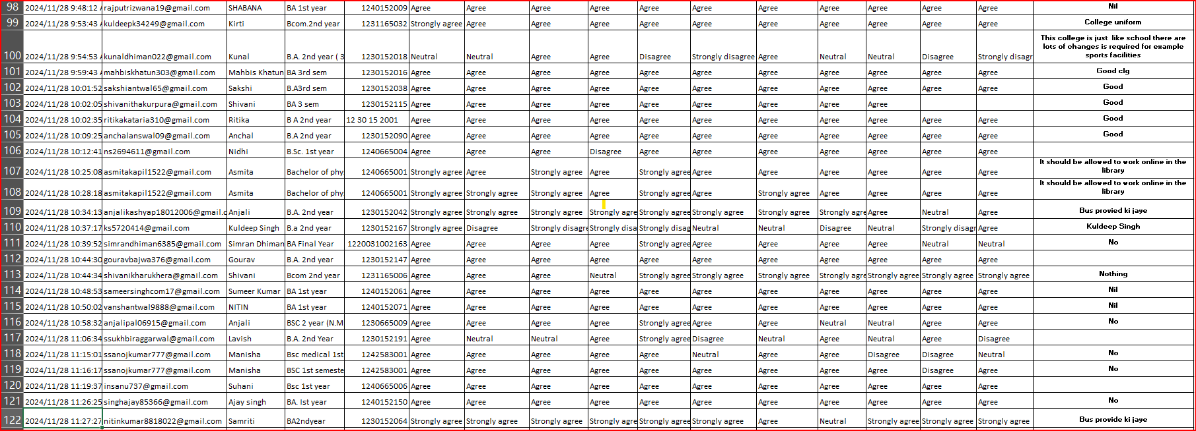
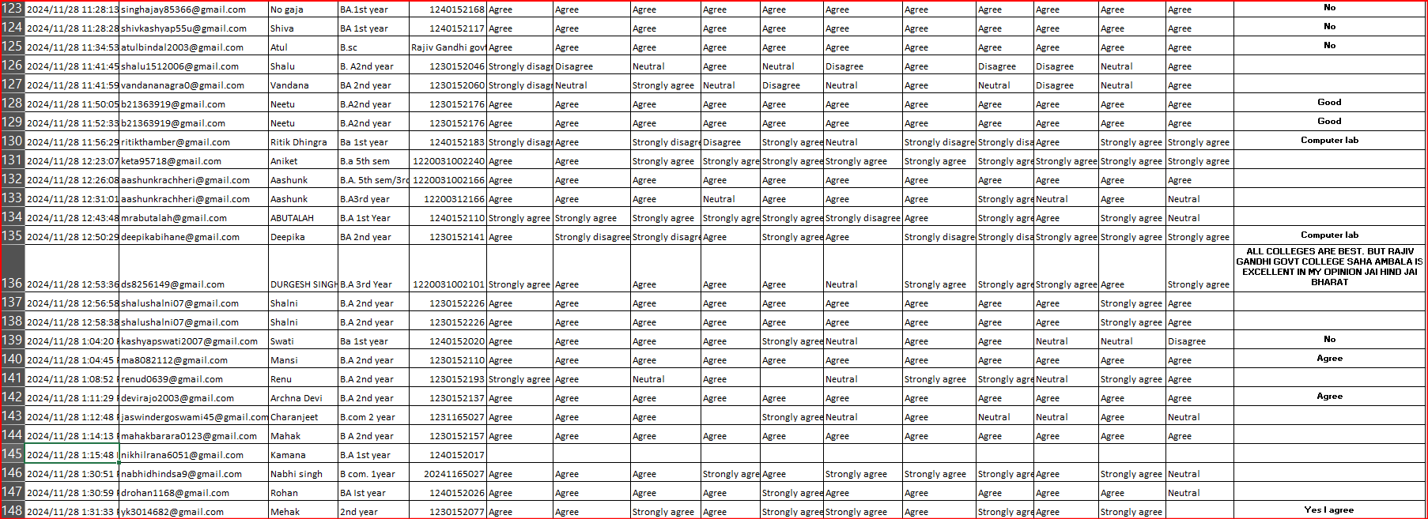

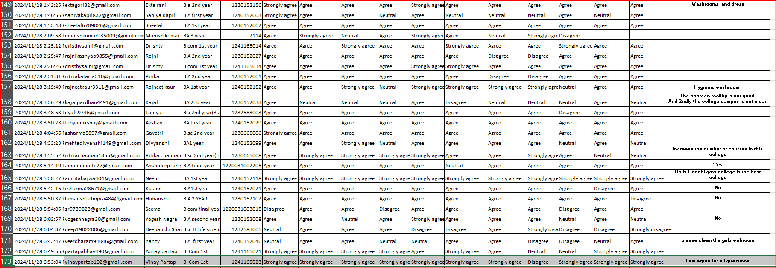

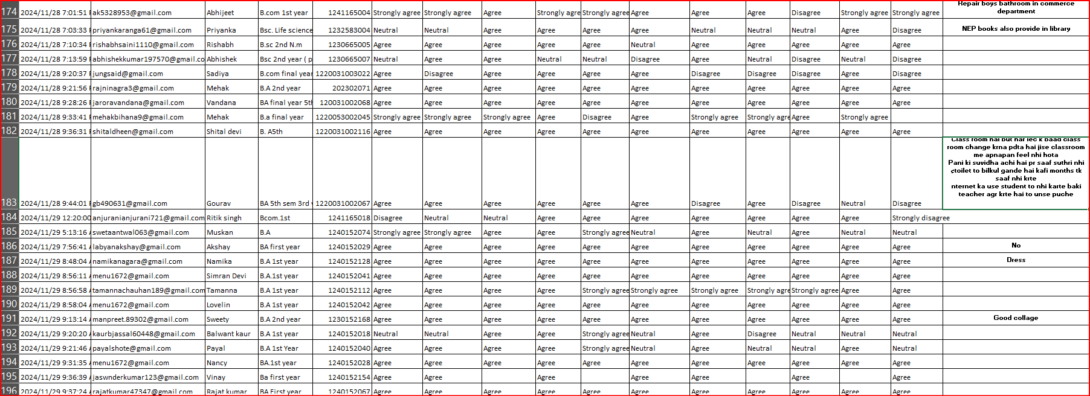

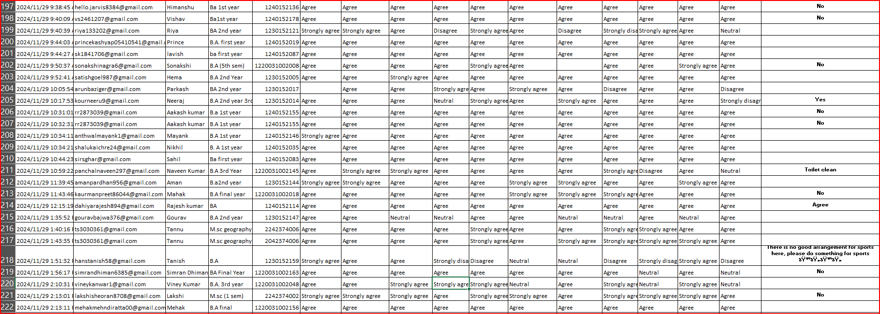

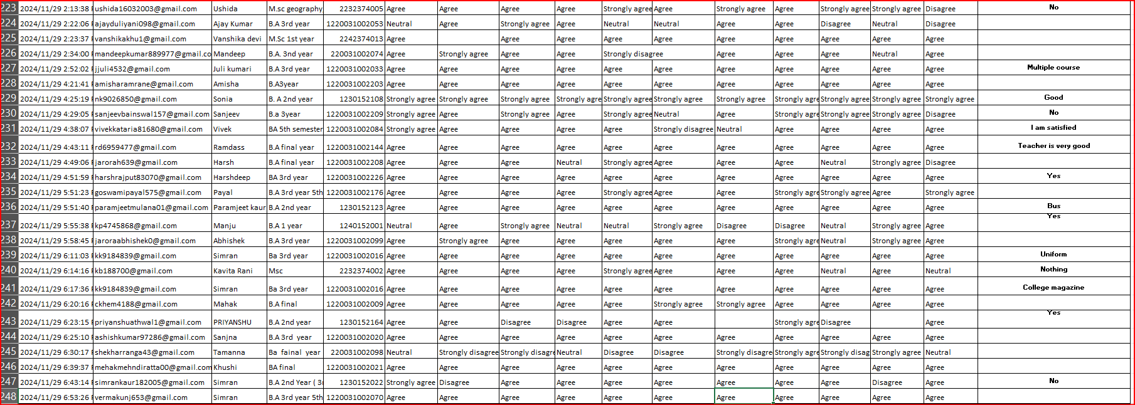

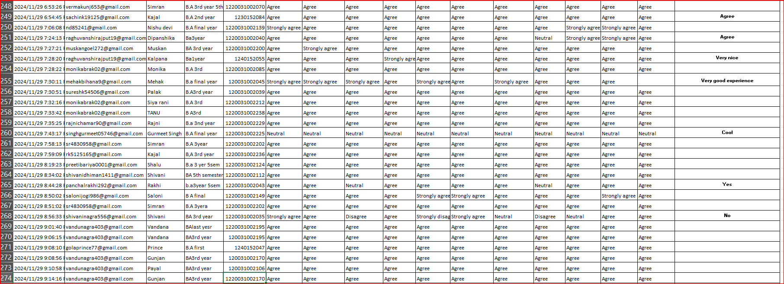
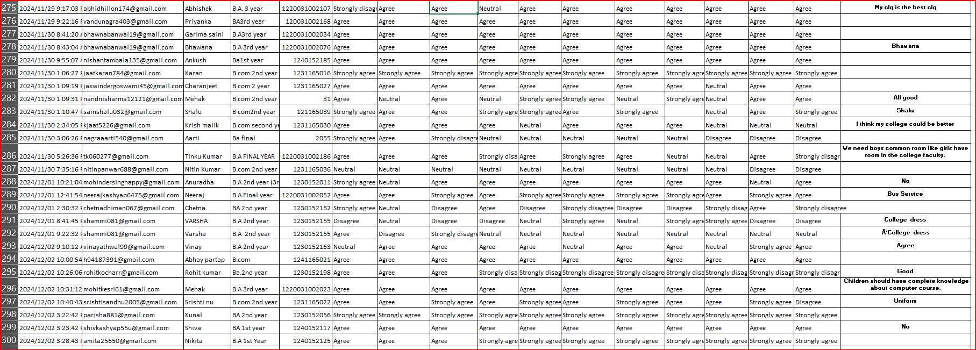

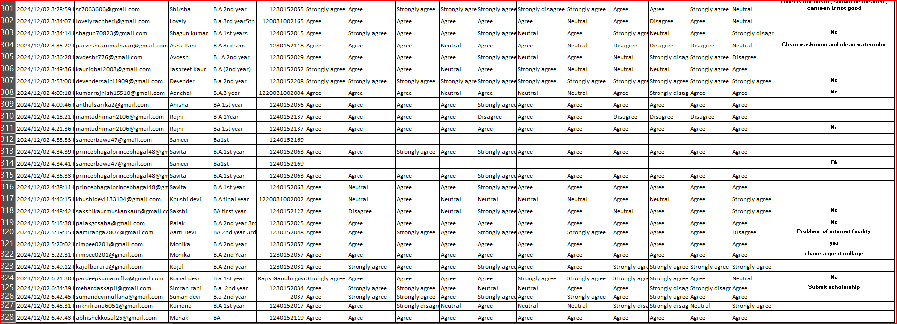

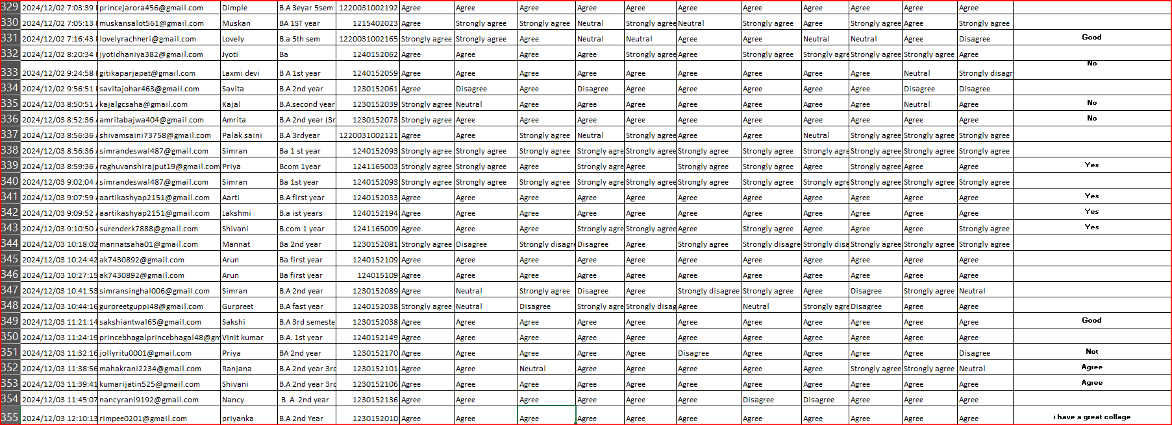

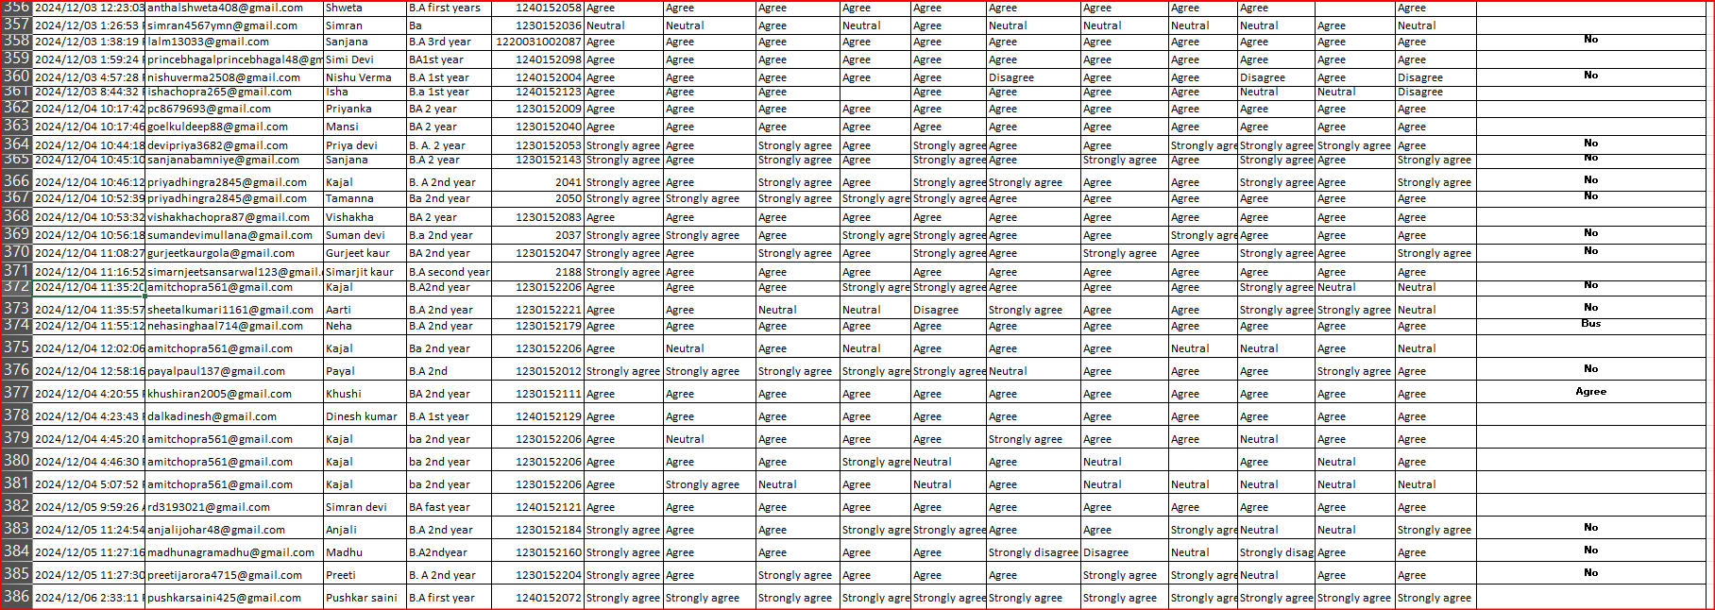

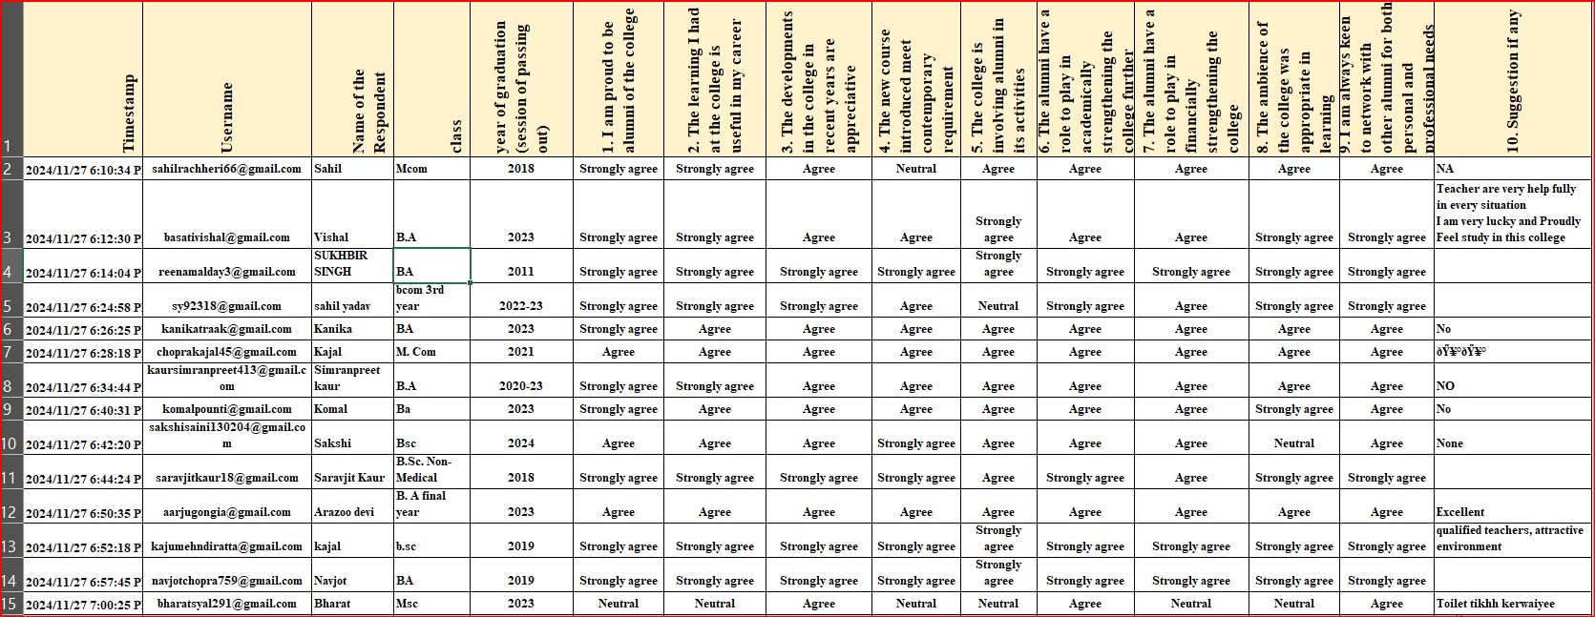

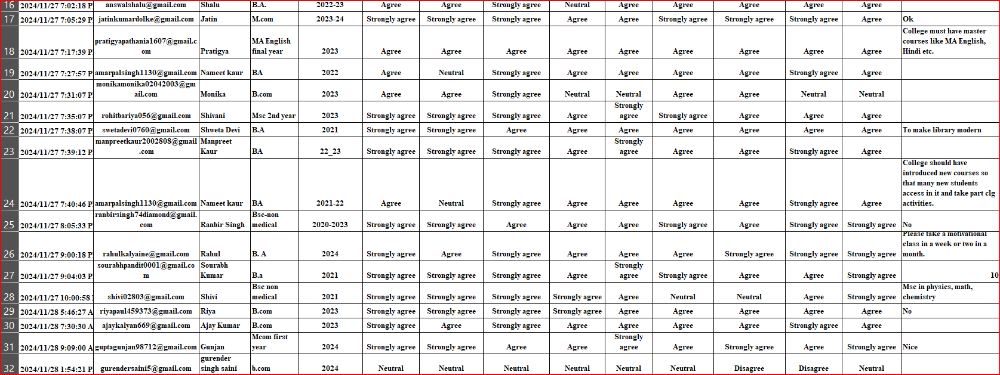

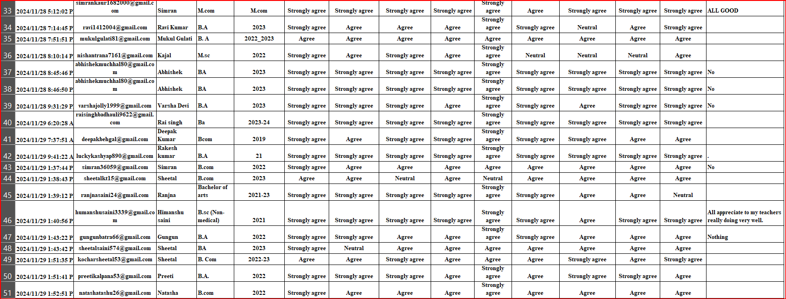

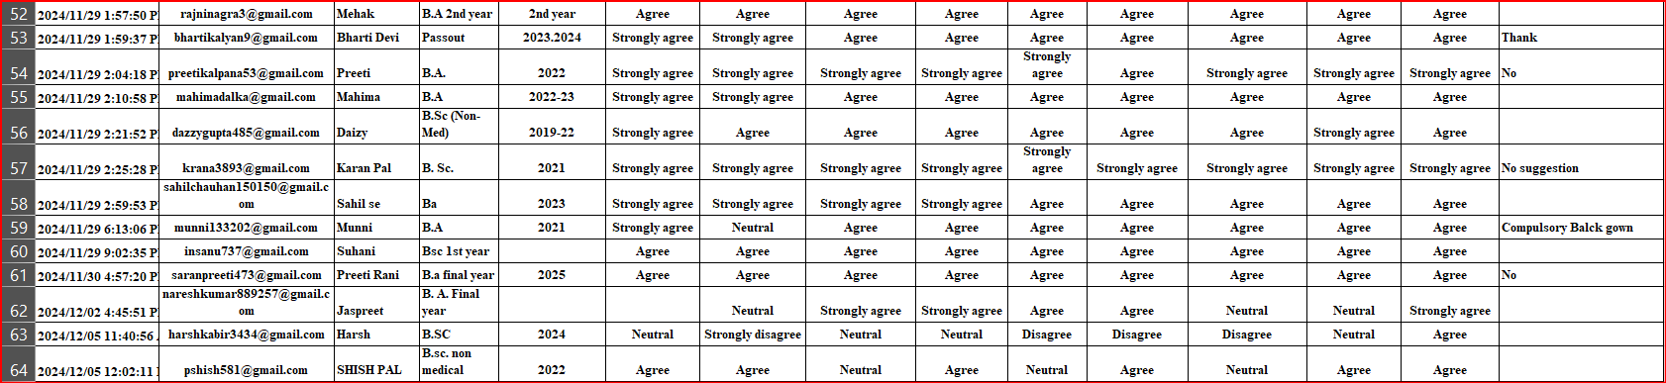

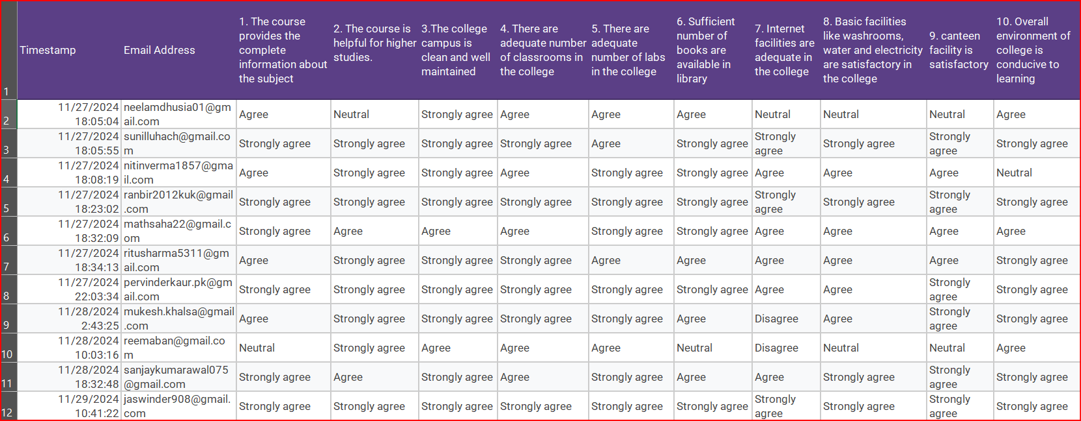

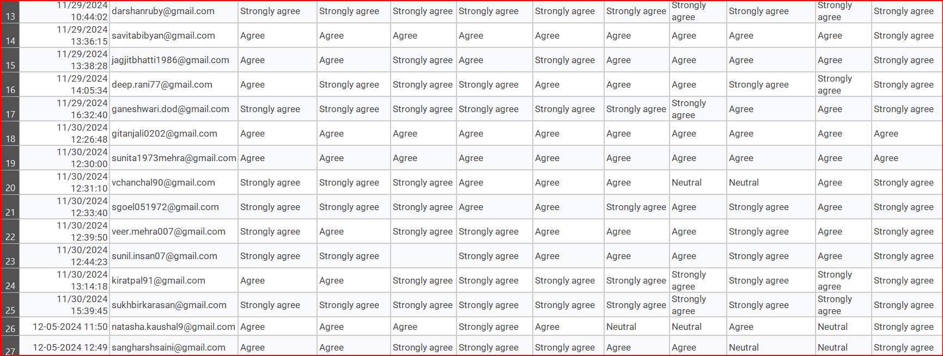

RAJIV GANDHI GOVT. COLLEGE SAHA (AMBALA)
Analysis of feedback received from students
STATEMENT | STRONGLY AGREE | AGREE | NEUTRAL | DISAGREE | STRONGLY DISAGREE
1. The prescribed syllabus provides complete knowledge of the subject | 82 | 262 | 19 | 7 | 6
2. The course was completed on time | 55 | 274 | 32 | 15 | 4
3. The assessments are conducted as per the schedule | 69 | 266 | 26 | 7 | 11
4. The evaluation process is fair and unbiased | 45 | 259 | 54 | 13 | 8
5. The college staff is cooperative and helpful | 117 | 219 | 20 | 15 | 7
6. The canteen facility in college is satisfactory. | 60 | 243 | 47 | 18 | 11
7. There is an adequate number of classrooms and labs in the college. | 58 | 263 | 38 | 12 | 7
8. The college campus is clean and well-ventilated | 66 | 236 | 44 | 23 | 9
9. Pure drinking water and hygienic washroom facilities are available in the college | 55 | 216 | 63 | 35 | 12
10. The prescribed books are available in the library. | 73 | 236 | 40 | 21 | 6
11. Internet facility is available in the college | 43 | 223 | 46 | 46 | 17

RAJIV GANDHI GOVT. COLLEGE SAHA (AMBALA)
Analysis of feedback received from Students

The table summarizes student feedback on various aspects of the institution, including the curriculum, academic performance, and facilities. Responses were gathered using a 5-point scale ranging from "Strongly Agree" to "Strongly Disagree." Below is an overview of the findings:
- Nearly 92% of students expressed agreement or strong agreement that the prescribed syllabus imparts complete subject knowledge, with 5% remaining neutral and 3% disagreeing.
- Around 87% agreed or strongly agreed that the syllabus was completed on time, while 8% were neutral and 5% expressed disagreement.
- For assessments being conducted as scheduled, 88% of students agreed or strongly agreed, 7% were neutral, and 5% disagreed.
- Approximately 80% of respondents viewed the evaluation process as fair and unbiased, 14% were neutral, and 5.5% disagreed.
- Regarding staff cooperation, 89% agreed or strongly agreed that the college staff is helpful and cooperative, 5% were neutral, and the rest held differing views.
- When asked about canteen facilities, 80% of respondents agreed or strongly agreed that the facility is satisfactory, 12% were neutral, and the remaining students disagreed.
- Feedback on labs and classrooms showed that 85% of students agreed or strongly agreed that these are sufficient, 10% were neutral, and 5% disagreed.
- On campus cleanliness and ventilation, 80% of students expressed satisfaction, 12% were neutral, and 8% disagreed.
- Pure drinking water availability received 71% agreement or strong agreement, with 16.5% neutral and 12% disagreeing.
- For library resources, 82% of students agreed or strongly agreed that enough books are available, 11% were neutral, and the remainder disagreed.
- Lastly, 70% of respondents agreed or strongly agreed that internet access is available in the college, 12% were neutral, and 17% disagreed.

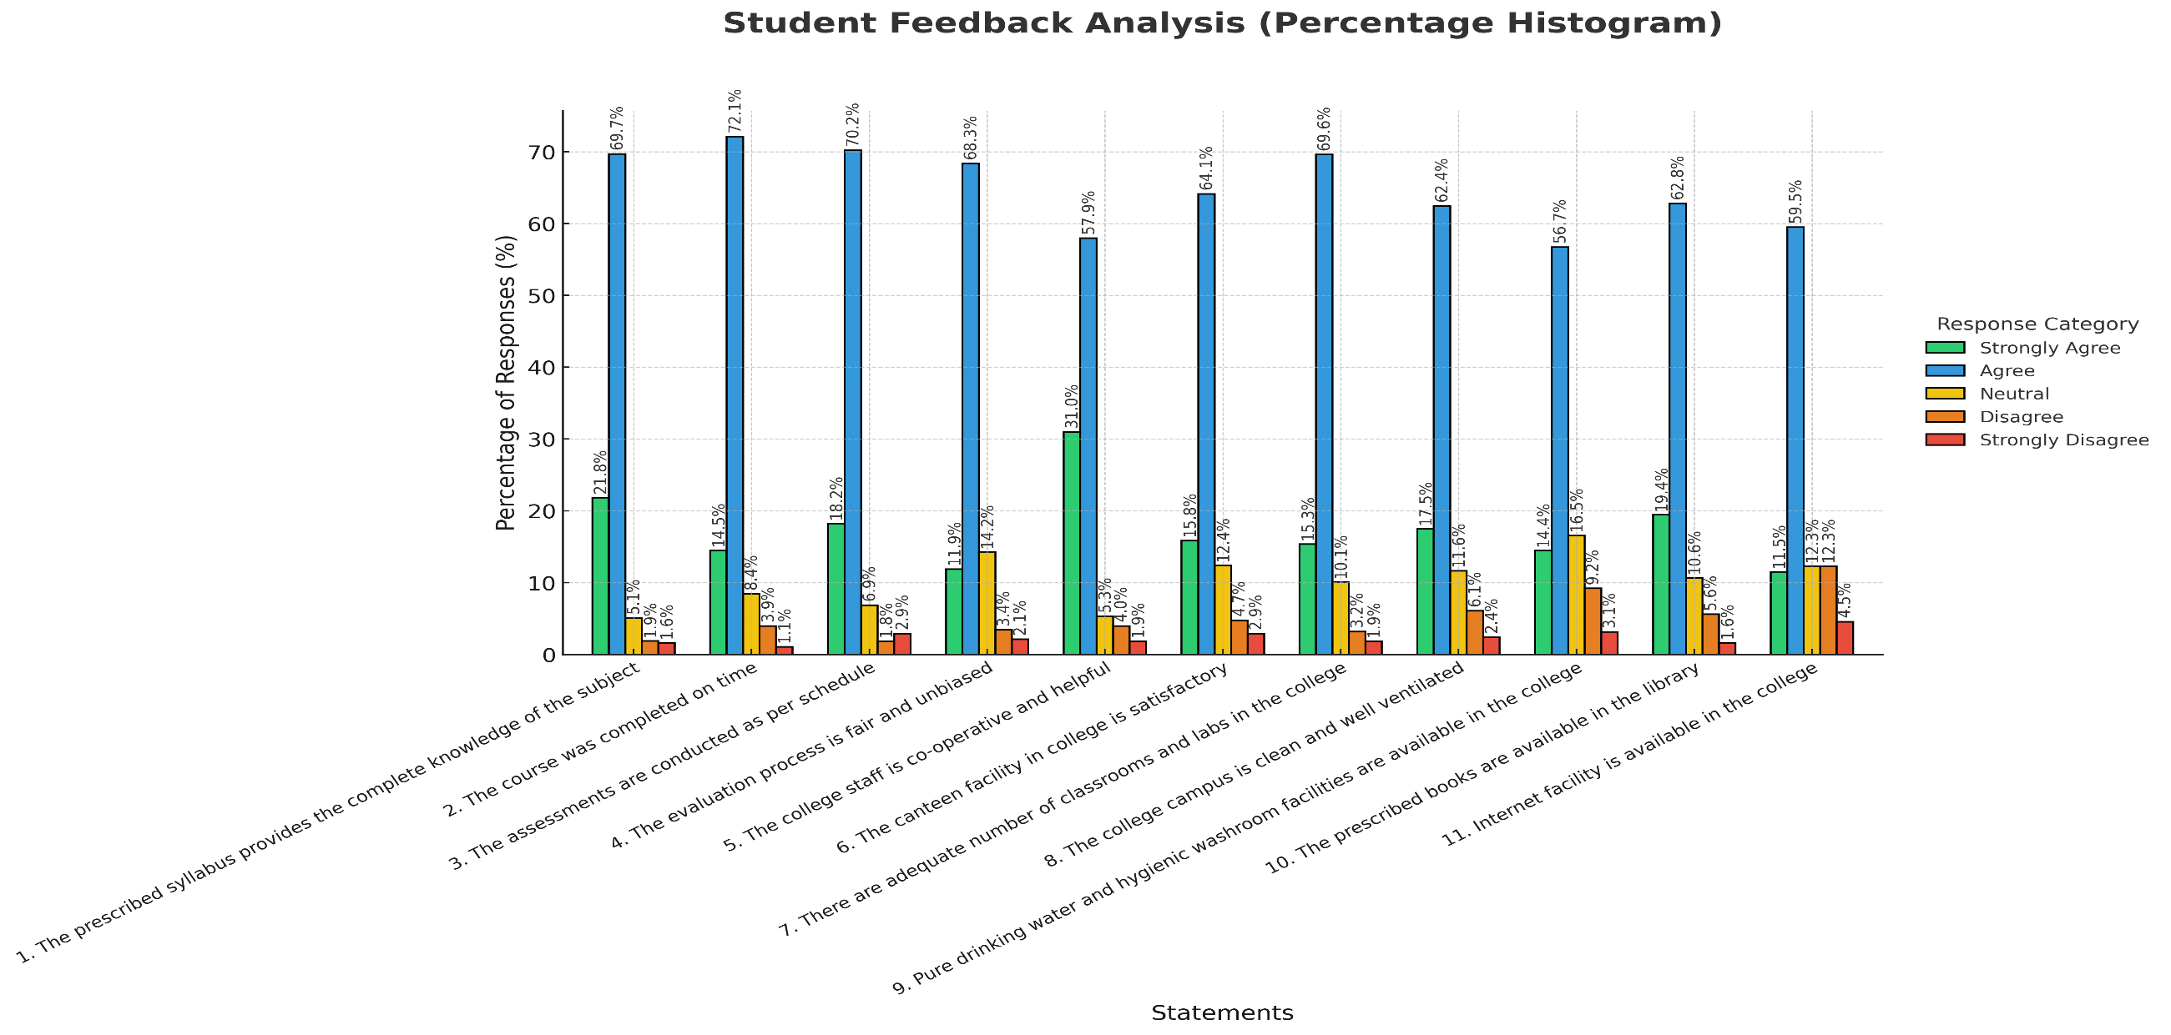

RAJIV GANDHI GOVT. COLLEGE SAHA (AMBALA)
Analysis of feedback received from Alumni
STATEMENT | STRONGLY AGREE | AGREE | NEUTRAL | DISAGREE | STRONGLY DISAGREE
1. I am proud to be an alumnus of the college | 44 | 15 | 3 | - | -
2. The learning I had at the college is useful in my career | 32 | 23 | 7 | 1 | -
3. The developments in the college in recent years are appreciative. | 33 | 26 | 4 | - | -
4. The new course introduced meets contemporary requirements. | 19 | 38 | 6 | - | -
5. The college is involving alumni in its activities. | 24 | 32 | 6 | 1 | -
6. The alumni have a role to play in academically strengthening the college further. | 20 | 39 | 3 | 1 | -
7. The alumni have a role to play in financially strengthening the college. | 16 | 39 | 6 | 2 | -
8. The ambience of the college was appropriate for learning. | 25 | 31 | 6 | 1 | -
9. I am always keen to network with other alumni for both personal and professional needs | 23 | 37 | 3 | - | -

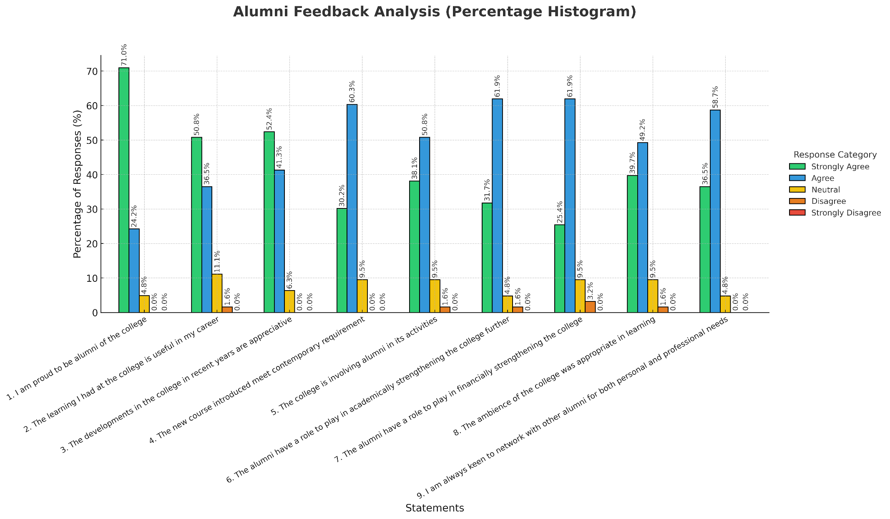

RAJIV GANDHI GOVT. COLLEGE SAHA (AMBALA)
Analysis of feedback received from Alumni
The table summarizes the feedback received from alumni regarding the institution's curriculum, academic performance, and overall environment. Alumni provided their responses on a 5-point scale ranging from strongly agree to disagree strongly. Key insights from the feedback are as follows:

- A significant 95% of alumni feel proud to be associated with the institution, reflecting a strong emotional and professional connection. Only 5% of respondents were undecided.
- Approximately 87% of alumni believe that the knowledge and skills acquired during their time at the college have been useful in their careers, showcasing the practical impact of the curriculum. About 11% remained neutral, while 2% disagreed.
- Around 94% of alumni appreciate the recent progress and initiatives undertaken by the institution, indicating satisfaction with its evolution. Meanwhile, 9% of respondents were neutral.
- Nearly 90% of alumni feel that the new courses introduced align well with contemporary industry and academic requirements. However, 10% were undecided.
- About 89% of respondents agreed or strongly agreed that alumni play an active role in college activities, highlighting their continued engagement. Only 10% remained neutral, and 1% disagreed.
- Approximately 94% of alumni believe they can contribute significantly to academically strengthening the college, reflecting a sense of responsibility toward its development. However, 4.8% were undecided, and 1.6% disagreed.
- Around 87% of respondents acknowledged their potential to contribute financially to the institution. A notable 10% were undecided, and only 3% disagreed, suggesting room for more awareness or initiatives.
- About 89% of alumni agree that the college provided an appropriate environment for learning, supporting academic and personal growth. Around 10% were undecided on this matter, and only 1% disagreed.
- Approximately 96% of alumni expressed willingness to network with fellow alumni for personal and professional benefits. Around 4% were neutral.

RAJIV GANDHI GOVT. COLLEGE SAHA (AMBALA)
Analysis of feedback received from Teachers
STATEMENT | STRONGLY AGREE | AGREE | NEUTRAL | DISAGREE | STRONGLY DISAGREE
1. The course provides complete information about the subject | 12 | 13 | 1 | - | -
2. The course is helpful for higher studies. | 15 | 10 | 1 | - | -
3. The college campus is clean and well-maintained | 15 | 10 | - | - | -
4. There are an adequate number of classrooms in the college | 15 | 11 | - | - | -
5. There are an adequate number of labs in the college | 13 | 13 | -- |  | -
6. A sufficient number of books are available in the library | 11 | 13 | 2 | - | -
7. Internet facilities are adequate in the college | 7 | 14 | 3 | 2 | -
8. Basic facilities like washrooms, water, and electricity are satisfactory in the college | 11 | 11 | 4 | - | -
9. The canteen facility is satisfactory | 10 | 12 | 4 | - | -
10. The overall environment of the college is conducive to learning | 20 | 5 | 1 | - | -

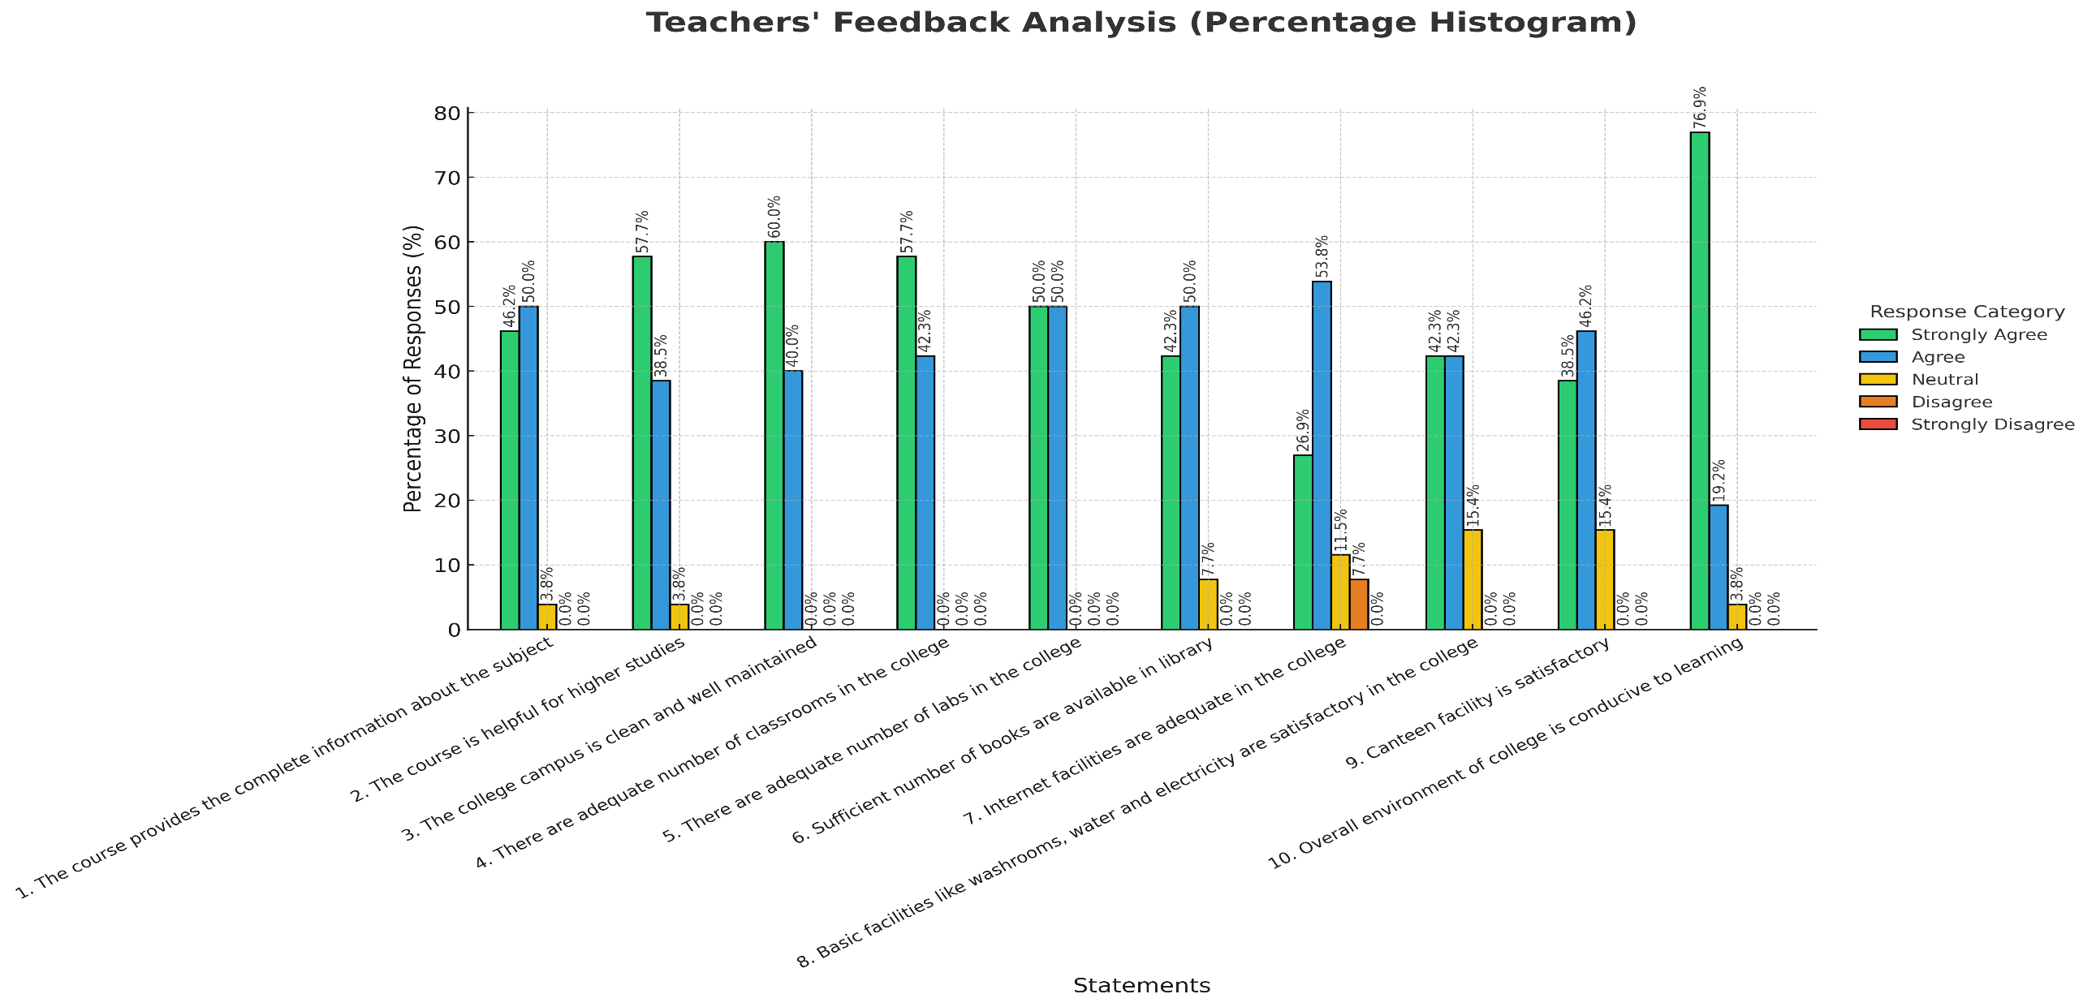

RAJIV GANDHI GOVT. COLLEGE SAHA (AMBALA)
Deep analysis of feedback received from Teachers
The above table summarizes the responses from teachers on aspects such as the prescribed curriculum, academic performance, and the institutional environment. Feedback was collected on a 5-point scale, with options ranging from Strongly Agree, Agree, Neutral, Disagree, to Strongly Disagree.
- Regarding whether the course provides complete information and knowledge about the subject, 96% of the teachers/respondents either agreed or strongly agreed with the statement, while 4% expressed no opinion.
- Nearly all the teachers (approximately 96%) agreed or strongly agreed that the prescribed curriculum supports higher studies; only 5% have no opinion.
- All 100% of the respondents agreed or strongly agreed that the college campus is clean and well-ventilated.
- On the adequacy of the number of classrooms, all 100% of the teachers agreed or strongly agreed.
- All teacher respondents (approximately 100%) agreed that the college has an adequate number of laboratories for practical subjects.
- Concerning the sufficiency of books in the college library, approximately 92% agreed or strongly agreed, while 8% expressed no opinion.
- Around 81% of the teachers agreed or strongly agreed that the college has an adequate number of internet facilities, while 11% were undecided, and 8% disagreed.
- Regarding basic facilities like washrooms, water, and electricity, 85% of teachers agreed or strongly agreed that the college provides satisfactory amenities, while 15% remained neutral.
- Approximately 85% of the respondents agreed or strongly agreed that the canteen facility is satisfactory, with 15% expressing no opinion.
- Finally, 96% of the teachers agreed or strongly agreed that the overall college environment is conducive to learning, while 4% remained neutral.

