
Rajiv Gandhi Government College, Saha (Ambala)
(Affiliated to Kurukshetra University Kurukshetra)

Criteria

Feed back report of students and analysis of report
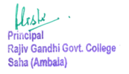

Feed Back Report of Students(Excel sheet report)
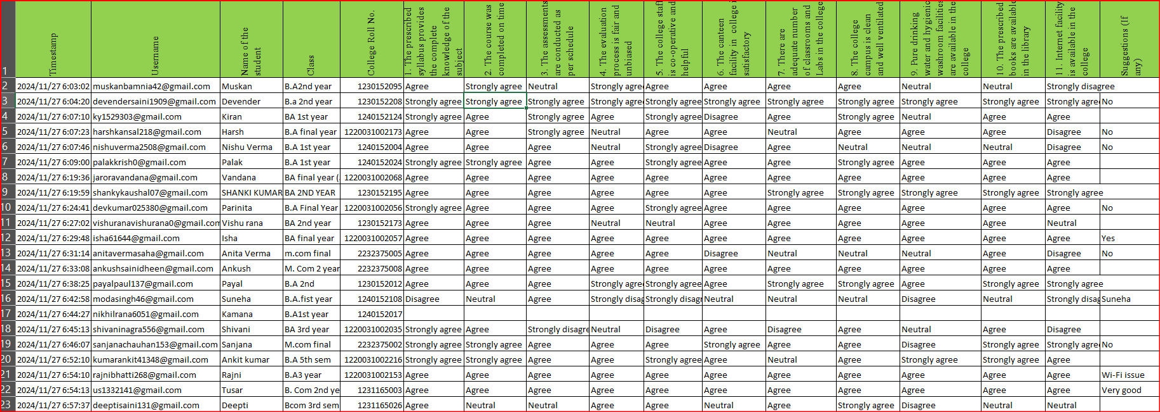
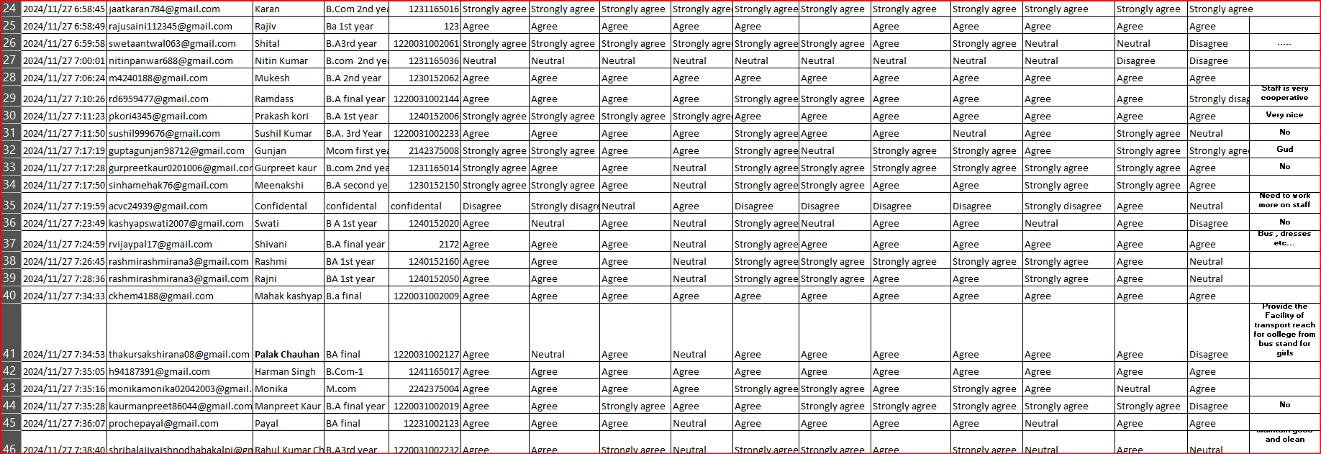
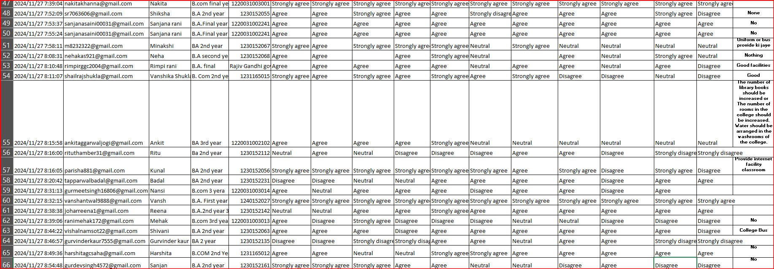
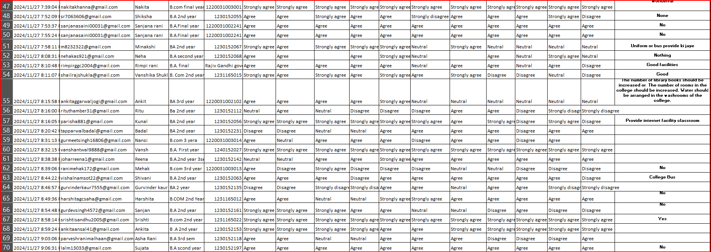
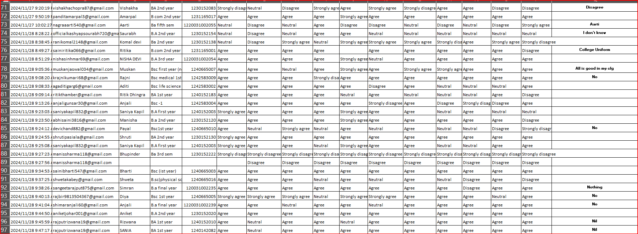
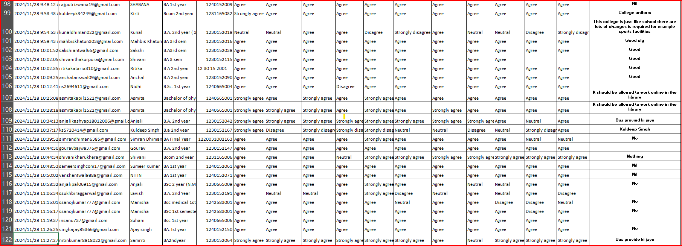
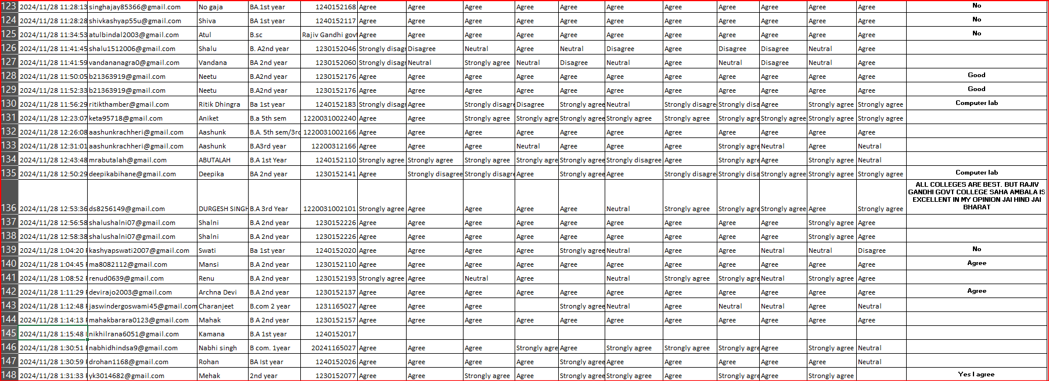
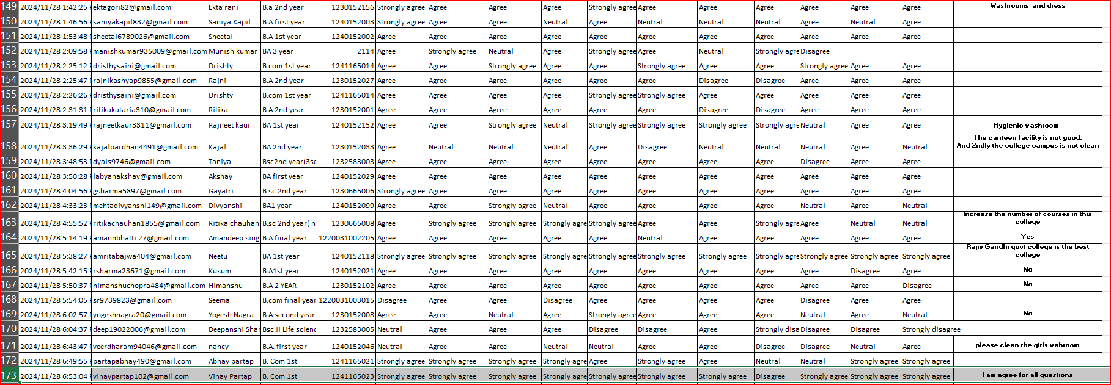
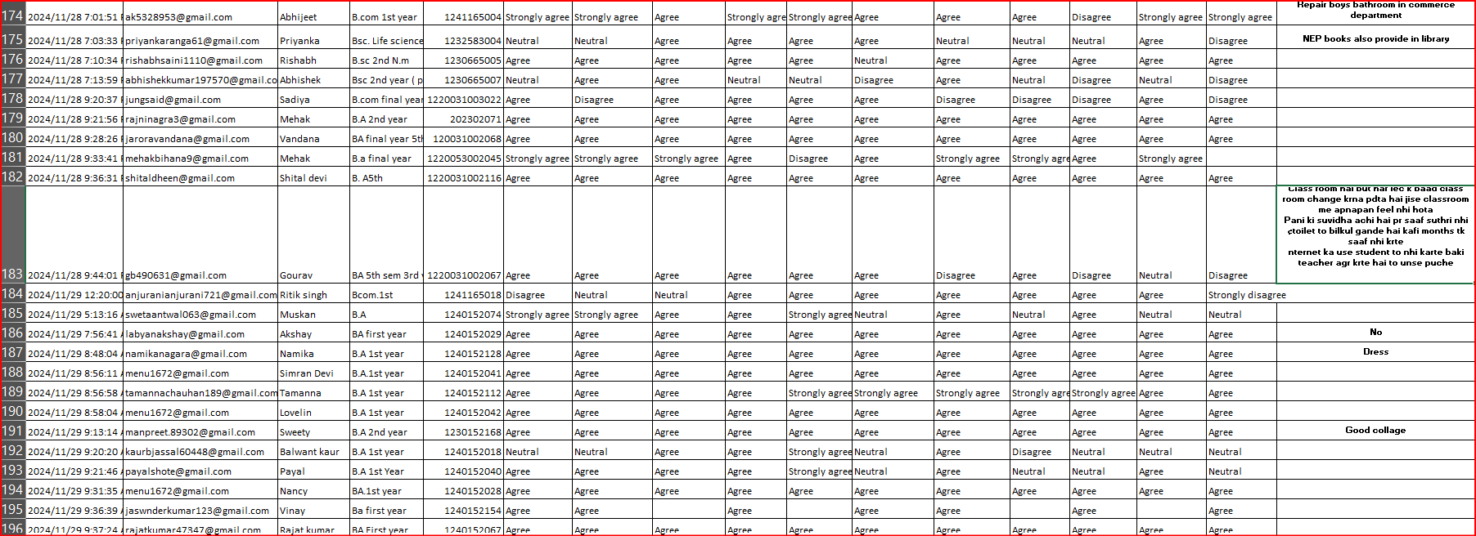
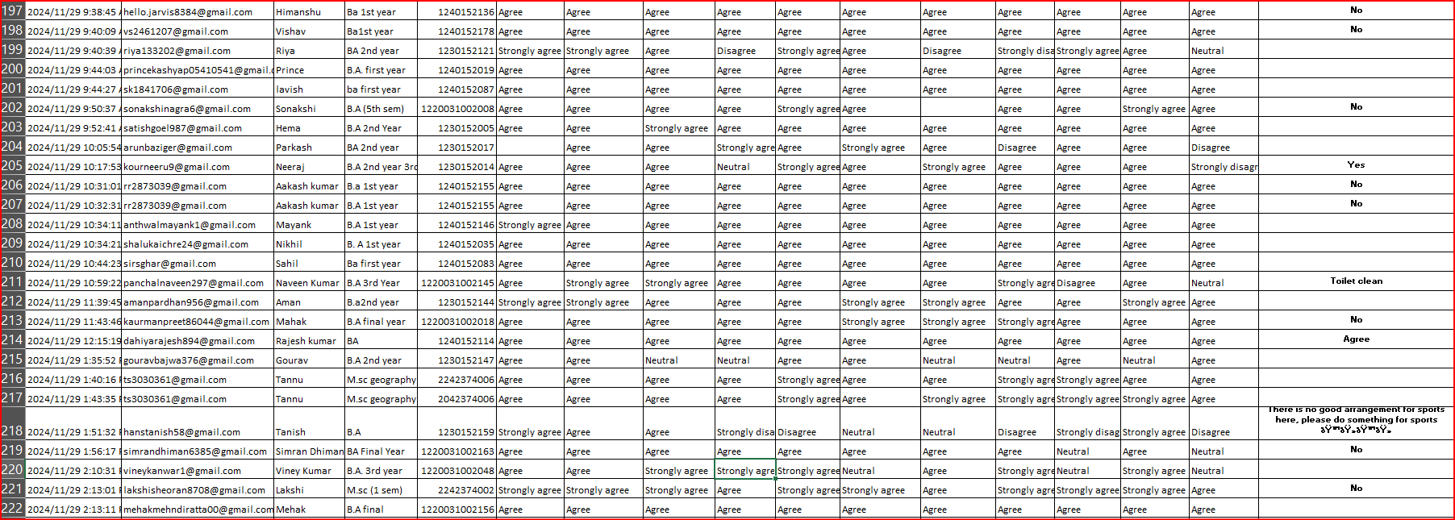
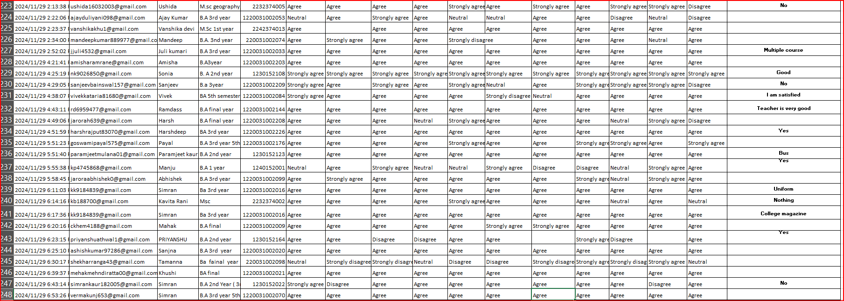
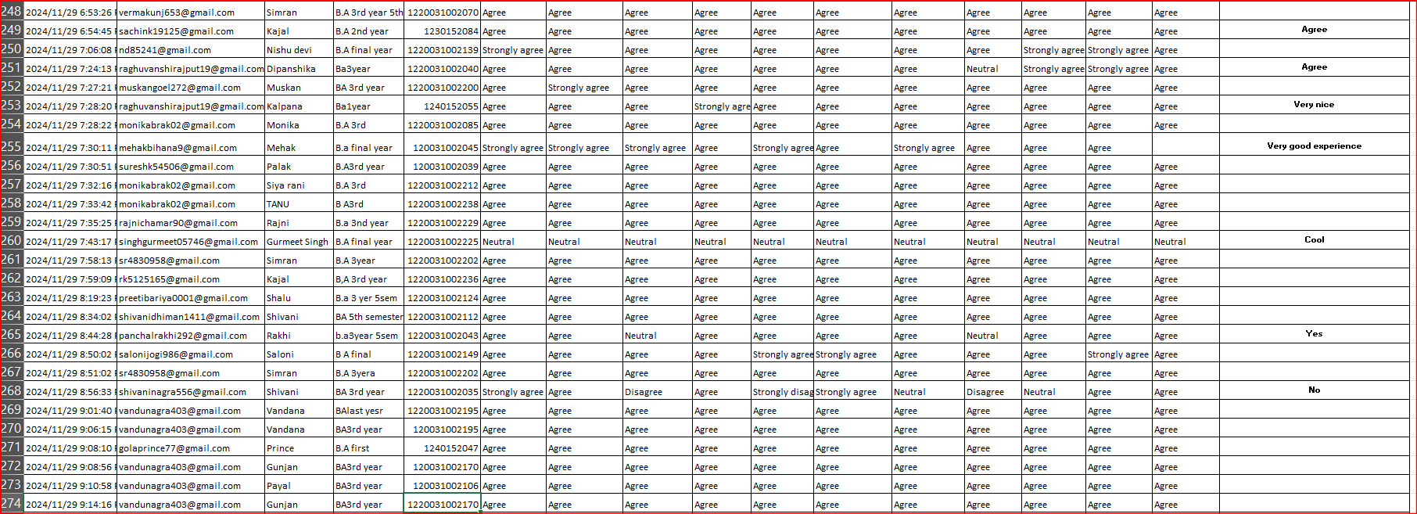
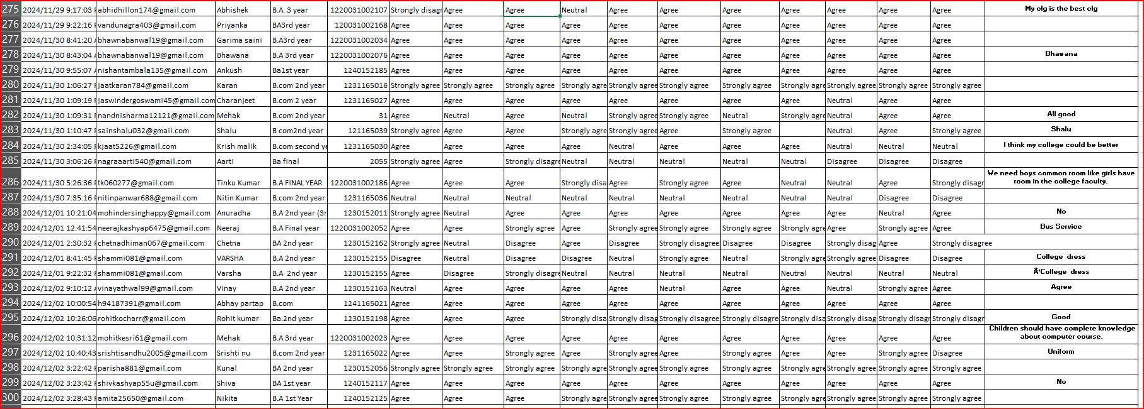
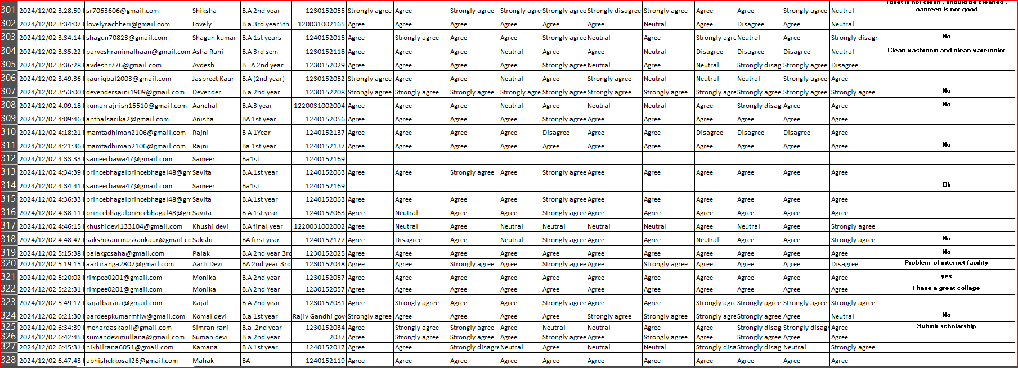
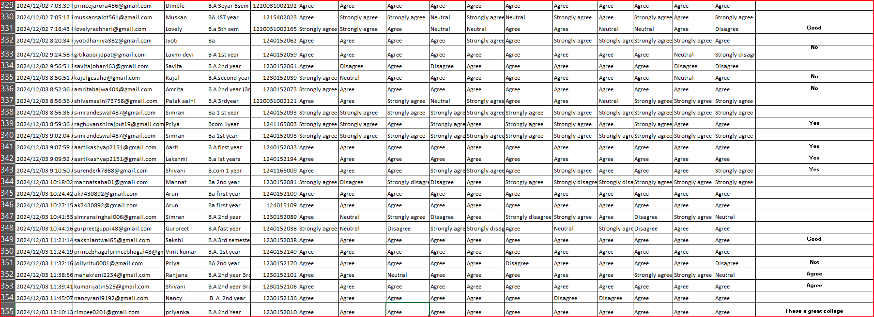
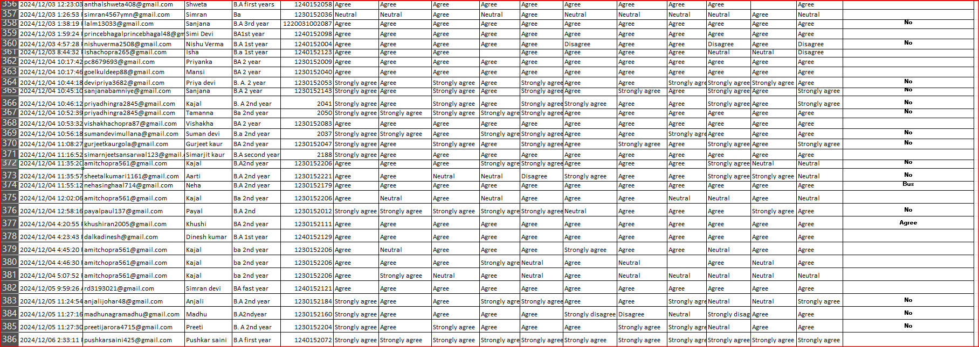
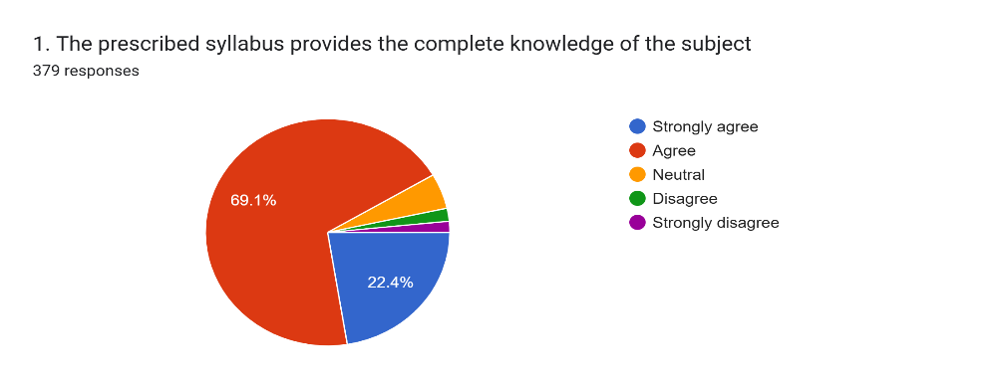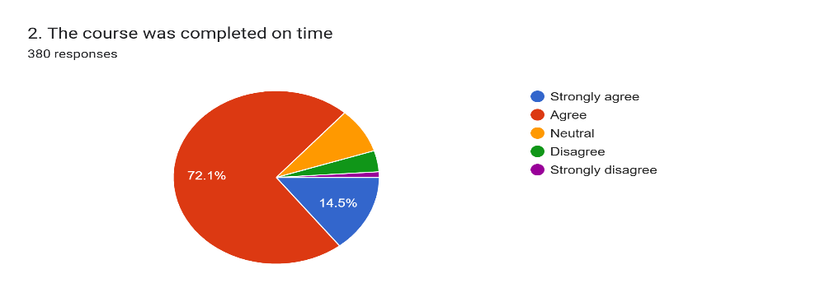
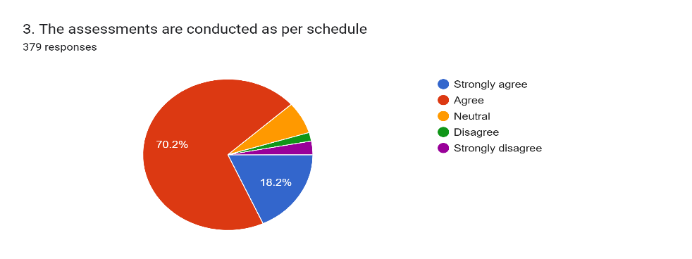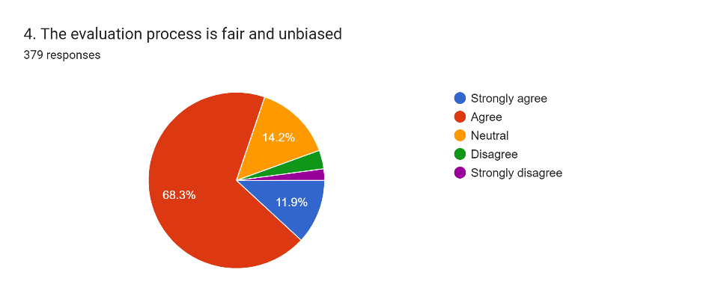
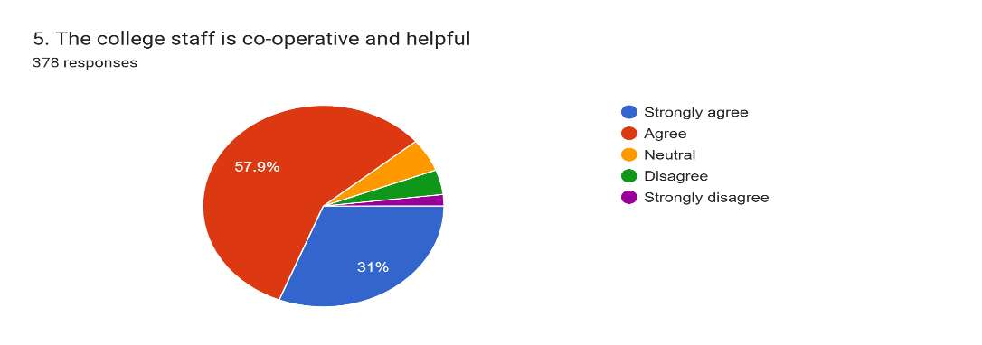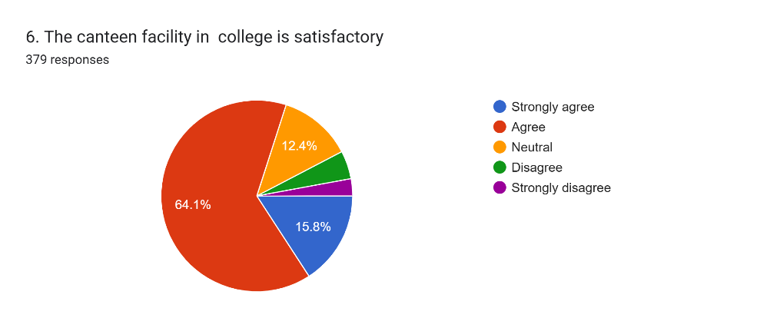
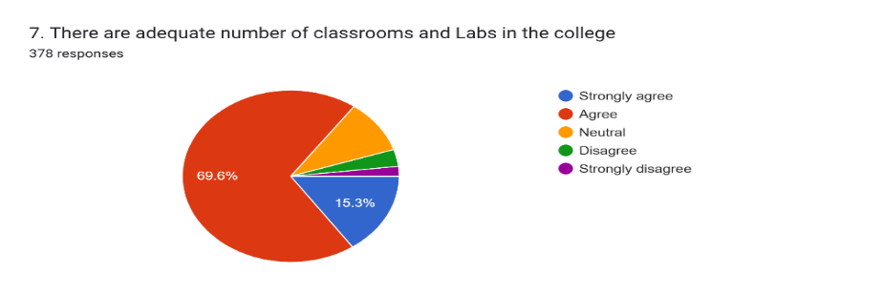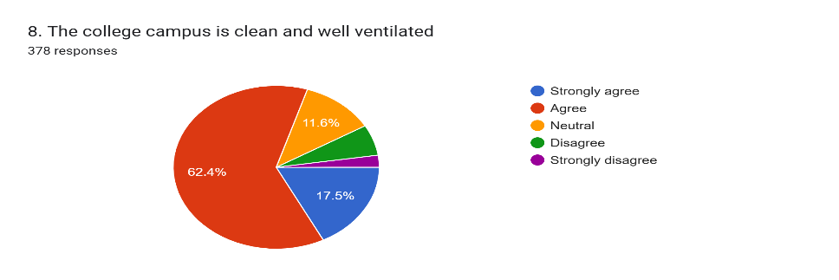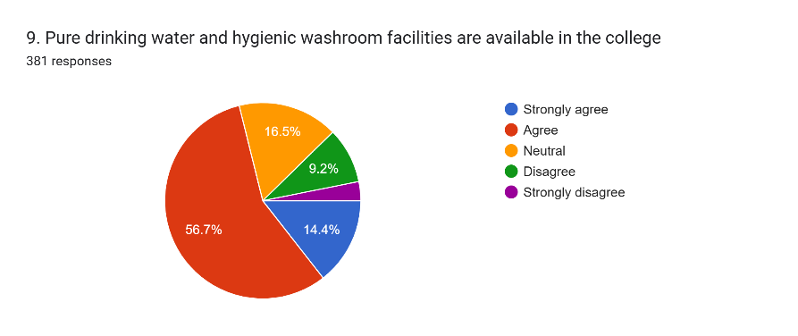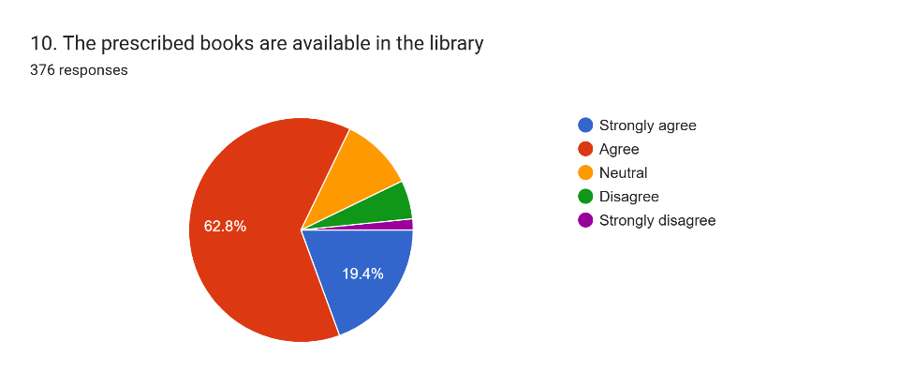
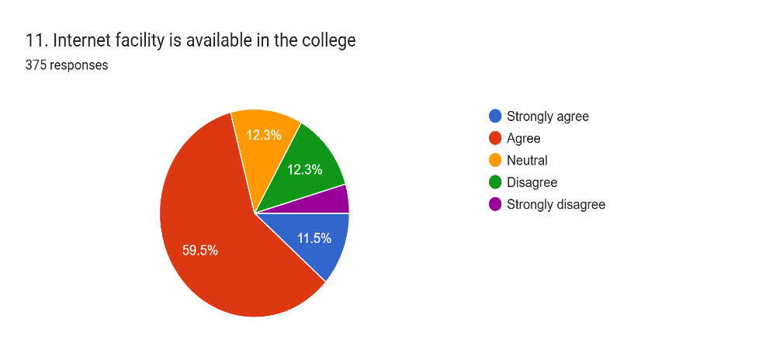
RAJIV GANDHI GOVT. COLLEGE SAHA (AMBALA)
Analysis of feedback received from Alumni
STATEMENT | STRONGLY AGREE | AGREE | NEUTRAL | DISAGREE | STRONGLY DISAGREE
1. The prescribed syllabus provides the complete knowledge of the subject | 82 | 262 | 19 | 7 | 6
2. The course was completed on time | 55 | 274 | 32 | 15 | 4
3. The assessments are conducted as per schedule | 69 | 266 | 26 | 7 | 11
4. The evaluation process is fair and unbiased | 45 | 259 | 54 | 13 | 8
5. The college staff is co-operative and helpful | 117 | 219 | 20 | 15 | 7
6. The canteen facility in college is satisfactory. | 60 | 243 | 47 | 18 | 11
7. There are adequate number of classrooms and labs in the college. | 58 | 263 | 38 | 12 | 7
8. The college campus is clean and well ventilated | 66 | 236 | 44 | 23 | 9
9. Pure drinking water and hygienic washroom facilities are available in the college | 55 | 216 | 63 | 35 | 12
10. The prescribed books are available in the library. | 73 | 236 | 40 | 21 | 6
11. Internet facility is available in the college | 43 | 223 | 46 | 46 | 17

RAJIV GANDHI GOVT. COLLEGE SAHA (AMBALA)
Analysis of feedback received from Students

The table summarizes student feedback on various aspects of the institution, including the curriculum, academic performance, and facilities. Responses were gathered using a 5-point scale ranging from "Strongly Agree" to "Strongly Disagree." Below is an overview of the findings:
- Nearly 92% of students expressed agreement or strong agreement that the prescribed syllabus imparts complete subject knowledge, with 5% remaining neutral and 3% disagreeing.
- Around 87% agreed or strongly agreed that the syllabus was completed on time, while 8% were neutral and 5% expressed disagreement.
- For assessments being conducted as scheduled, 88% of students agreed or strongly agreed, 7% were neutral, and 5% disagreed.
- Approximately 80% of respondents viewed the evaluation process as fair and unbiased, 14% were neutral, and 5.5% disagreed.
- Regarding staff cooperation, 89% agreed or strongly agreed that the college staff is helpful and cooperative, 5% were neutral, and the rest held differing views.
- When asked about canteen facilities, 80% of respondents agreed or strongly agreed that the facility is satisfactory, 12% were neutral, and the remaining students disagreed.
- Feedback on labs and classrooms showed that 85% of students agreed or strongly agreed that these are sufficient, 10% were neutral, and 5% disagreed.
- On campus cleanliness and ventilation, 80% of students expressed satisfaction, 12% were neutral, and 8% disagreed.
- Pure drinking water availability received 71% agreement or strong agreement, with 16.5% neutral and 12% disagreeing.
- For library resources, 82% of students agreed or strongly agreed that enough books are available, 11% were neutral, and the remainder disagreed.
- Lastly, 70% of respondents agreed or strongly agreed that internet access is available in the college, 12% were neutral, and 17% disagreed.

