
Rajiv Gandhi Government College, Saha (Ambala)
(Affiliated to Kurukshetra University Kurukshetra)

Criteria 1.1

Feed back report of Teachers and analysis of report



Feed back report of teachers
Excel Sheet Report
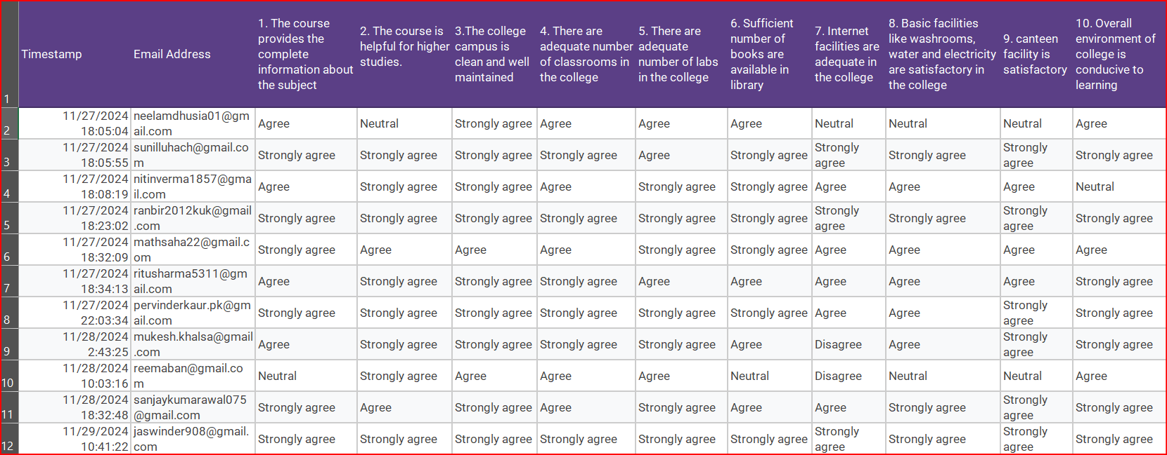
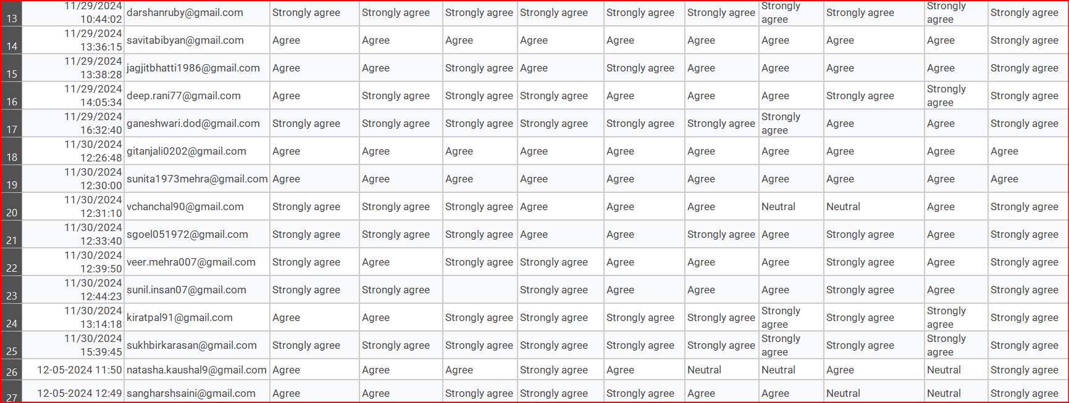

Analysis of feed back form( SCREEN SHOTS OF GOOGLE FORM)
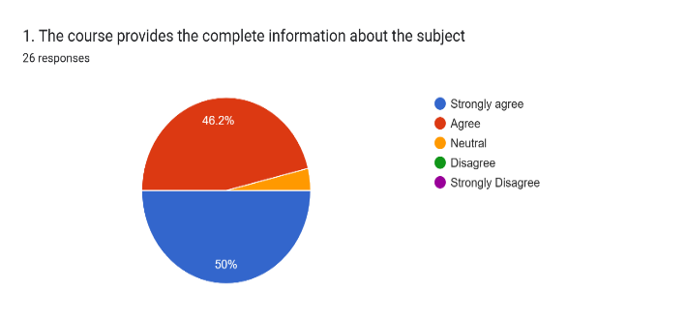

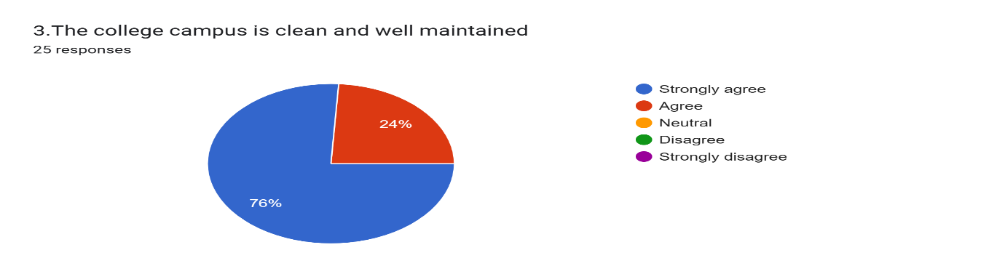
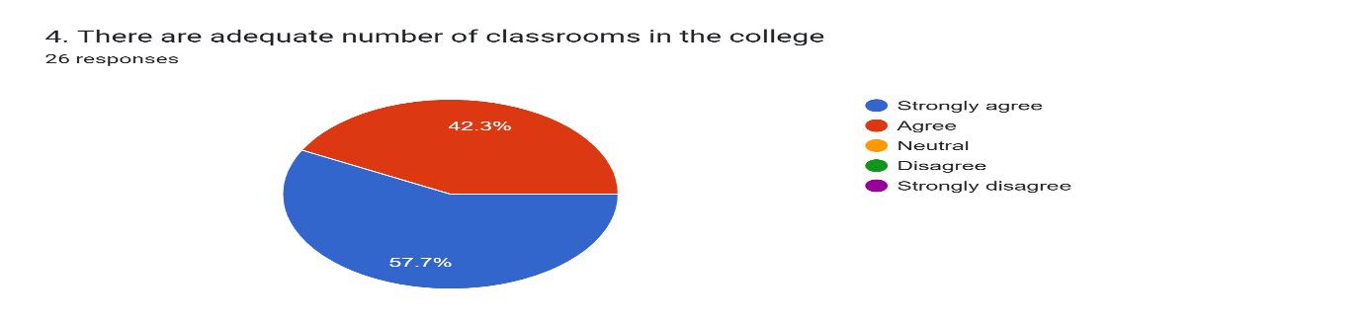
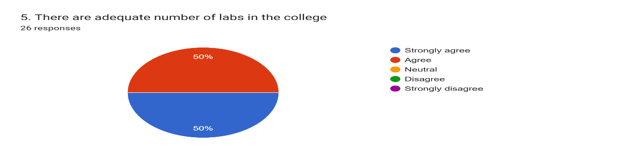
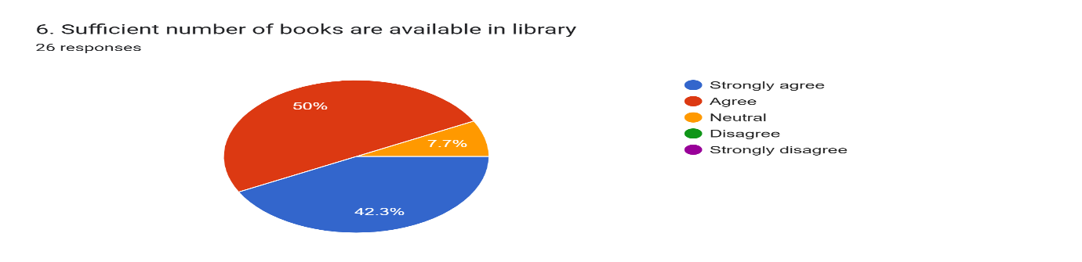

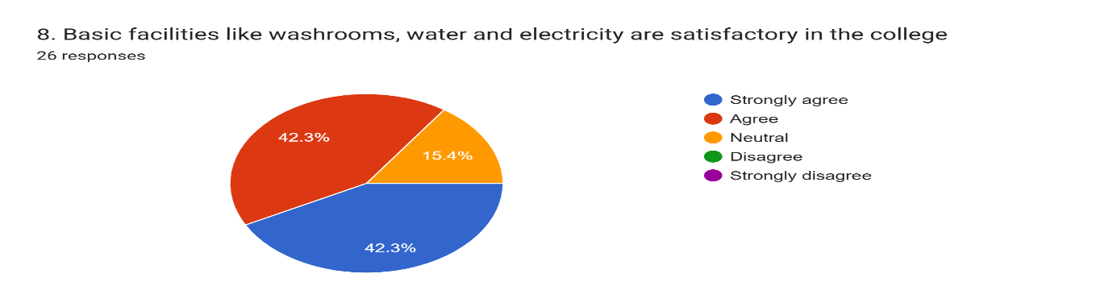
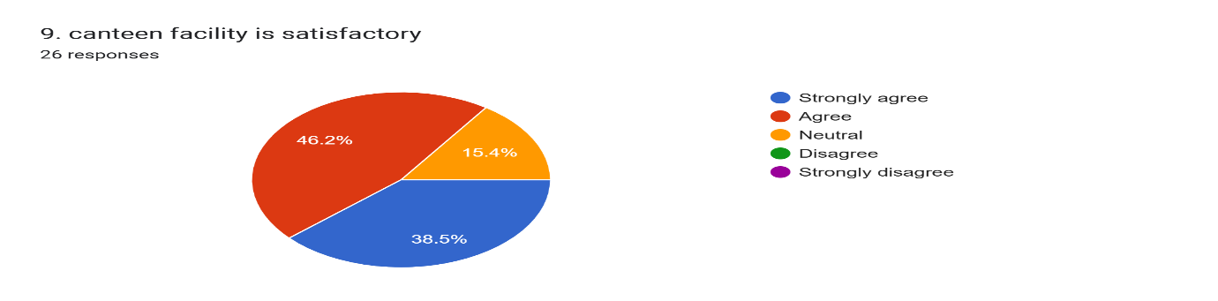
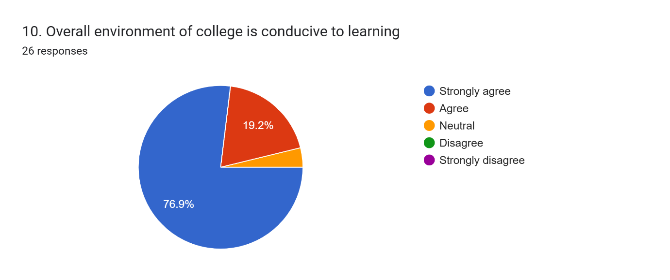
RAJIV GANDHI GOVT. COLLEGE SAHA (AMBALA)
Analysis of feedback received from Teachers
STATEMENT | STRONGLY AGREE | AGREE | NEUTRAL | DISAGREE | STRONGLY DISAGREE
1. The course provides the complete information about the subject | 12 | 13 | 1 | - | -
2. The course is helpful for higher studies. | 15 | 10 | 1 | - | -
3.The college campus is clean and well maintained | 15 | 10 | - | - | -
4. There are adequate number of classrooms in the college | 15 | 11 | - | - | -
5. There are adequate number of labs in the college | 13 | 13 | -- |  | -
6. Sufficient number of books are available in library | 11 | 13 | 2 | - | -
7. Internet facilities are adequate in the college | 7 | 14 | 3 | 2 | -
8. Basic facilities like washrooms, water and electricity are satisfactory in the college | 11 | 11 | 4 | - | -
9. canteen facility is satisfactory | 10 | 12 | 4 | - | -
10. Overall environment of college is conducive to learning | 20 | 5 | 1 | - | -

RAJIV GANDHI GOVT. COLLEGE SAHA (AMBALA)
Deep analysis of feedback received from Teachers
The above table summarizes the responses from teachers on aspects such as the prescribed curriculum, academic performance, and the institutional environment. Feedback was collected on a 5-point scale, with options ranging from Strongly Agree, Agree, Neutral, Disagree, to Strongly Disagree.
- Regarding whether the course provides complete information and knowledge about the subject, 96% of the teachers/respondents either agreed or strongly agreed with the statement while 4% expressed no opinion.
- Nearly all the teachers (approximately 96%) agreed or strongly agreed that the prescribed curriculum supports higher studies, only 5% have no opinion.
- All 100% of the respondents agreed or strongly agreed that the college campus is clean and well-ventilated.
- On the adequacy of the number of classrooms, all 100% of the teachers agreed or strongly agreed.
- All teacher respondents (approximately 100%) agreed that the college has an adequate number of laboratories for practical subjects.
- Concerning the sufficiency of books in the college library, approximately 92% agreed or strongly agreed, while 8% expressed no opinion.
- Around 81% of the teachers agreed or strongly agreed that the college has an adequate number of internet facilities, while 11% were undecided, and 8% disagreed.
- Regarding basic facilities like washrooms, water, and electricity, 85% of teachers agreed or strongly agreed that the college provides satisfactory amenities, while 15% remained neutral.
- Approximately 85% of the respondents agreed or strongly agreed that the canteen facility is satisfactory, with 15% expressing no opinion.
- Finally, 96% of the teachers agreed or strongly agreed that the overall college environment is conducive to learning, while 4% remained neutral.

